M.A. GEOGRAPHY
SEMESTER - I
- The M.A. Semester - I examination in Geography shall consist of 500 Marks. There shall be four theory papers each of 100 marks and one practical of 100 Marks as follows :-

Paper | Title | External |  | Internal |  | Total
 |  | Mx. | Min. | Mx. | Min
I | Geomorphology | 80 | 29 | 20 | 7 | 100
II | Climatology | 80 | 29 | 20 | 7 | 100
III | Evolution of Geographical Thought | 80 | 29 | 20 | 7 | 100
IV | Geography of India | 80 | 29 | 20 | 7 | 100
V | Practical – Instrumental Survey |  |  |  |  | 100

- The theory papers shall be of three hours duration.
- Candidate will be required to pass separately in theory and practical Examination.
- (a) In the practical examination the following shall be the allotment of time and marks.
(i) Field work : 70 Marks
(ii) Viva on (i) & practical Record : 30 Marks
(b) The external and internal examiner shall jointly submit marks.
(c) All the candidates shall present at the time of the practical examination. Their practical record regularly singed by the teachers concerned.
(d) Candidate will be required 36% of marks to pass external and internal Examination separately.

SEMESTER – I (Geography)
GEOMORPHOLOGY
paper - I
OBJECTIVES :-
- It being a course at the interface of Geography with earth, the student has to be sensitized to background knowledge of geography and environmental sciences.
- The objectives of the course is to familiarze the students with the need for understanding of geomorphology with reference to certain fundamental concepts, focusing on the unity of geomorphology in the earth materials and the Process component of geomorphology is segmented into the internal and external processes of landscape evolution.
- Finally a few selected applications of geomorphology to social requirements and quality of environment are dealt with.

COURSE CONTENTS :-

- Nature and scope of Geomorphology; Fundamental concepts-Geological Structures and landforms, uniformitarians, multicyclic and polygenetic evolution of landscapes, concept of thresold, Environmental change – climatic change and geochronological methods-documentary evidence, artifacts.
- Earth movements – epeirogentic, orogenetic and cymatogenic earth movements. Forces of crustal instability, isostasy, plate tectonics, Interior of the earth and earth quake, Vulcanicity, oroganic structures with reference to the evolution of the Himalaya.
- Exogenetic Processes : Concept of gradation, Agents and processes of gradiation, causes, types and classification of weathering, mass movement erosional, and depositional processes and resultant landforms and soil formation. Slope evolution; down warping by Davis, parallel retreat and slope replacement models by Penck.
- Geomorphic processes; Dynamics of fluvial, glacial, periglacial, Aeolian (Arid & Semi Arid), marine and karst processes and resulting landforms, Erosion surfaces. Applied geomorphology, urban geomorphology, environmental geomorphology and Natural Hazards.
Suggested Readings :-
- Chorley. R.J. Spatial Analysis in Geomorphology, Methuen, London 1972.
- Garner, H.F. : The Origin of landscape - A Synthesis of Geomorphology, Oxford University Press, London, 1974.
- Sharma, H.S. (ed.) : Perspectives in Geomorphology, Concept. New Delhi 1980.
- Singh, S : Geomorphology, Prayag Publication. Allahabad 1998.
- Thombury, W.D. Principles of Geomorphology, John Wiloy, New York 1960.
- dkSf’kd] ,l-Mh- % Hkw&vkd`fr foKku
- usxh] ch-,l- % Hkw&vkd`fr foKku
- flag] lfoUnz ds- % Hkw&vkd`fr foKku] ‘kkjnk iqLrd Hkou] bykgkckn
- ;kno rFkk jkelqjs’k % Hkw&vkd`fr foKku] xzUFk dkuiqj
- xk;=h izlkn % Hkw&vkd`fr foKku

PEDAGOGY :-
Geomorophology is essentially a field scienct, there students be taken to the field for effective understanding of geomorphic forms and processes. Department must have good geomorphic lab equipped with photographs of land forms of various climatic regions and loposheets of Survey of India.

CLIMATIOLOGY
paper - II
OBJECTIVES :
The main objectives of the course is to provide.
Understanding of weather phenomena and generation of climatic phenomena and Dynamics of global climate.

Course Contents :-
- Nature and scope of climatology and its relationship with meteorology.
- Composition and structure of atmosphere.
- Insolation and heat balance of the earth. Green house effect.
- Temperature :- Vertical, horizontal and regional distribution.
- Air pressure
- Atmospheric motion :- Parmanent wind, Local wind, and Jet stream, and monsoon winds.
- General circulation in the atmoshpere :- Humidity, evoparation and condensation (form of condensation).
- Precipitation :- Types world pattern precipitation, Acid rain.
- Concept of Air masses and fronts. Cyclones.
- Ocean admospheric interaction - EL Nino, and La Nina.
- Classification of climates :- World classification of climate. according to koppen, Thorntwaite, General classification of world climate.

SUGGESTED READEINGS :-
1. Barry, R.G. and Chorley P.J. : Atomosphere, Weather and Climate, routledge London and New York, 1998.
2. Critchfield JH : General Climatology. Prentice Hall, India. New Delhi. 1987.
3. Das, P.K. : Monsoons National Book Trust. New Delhi, 1987.
4. Fein, J. S. and stephens, P. N. : Monosoons Wiley Interscience.
5. India Met. Deptt. Climatological Tables of Observatories in India. Govt. of India 1968.
6. Lal D.S. : Climatology, Chaitanya publication, Allahabad. 1986.
7. Lydolph. P.E. : The Climate of the Earth. Rowman. 1985.
8. Menon P.A. : Our Weather, N.B.T. New Delhi, 1989.
9. Peterson, S. : Introduction to Meteorology Mc Graw Hill Book. London. 1969.
10. Robinson. : P.J. and Henderson S: Contemporary Climatology. Henlow. 1999.
11. Tompson, R.D. and Perry. A (ed) : Applied Climatology, Principles and Practice.
12. flag] lafoUnz % tyok;q foKku]
13. xkSre] vydk % tyok;q ,oa leqnz foKku
14. yky] Mh- ,l- % tyok;q foKku

EVOLUTION OF GEOMORPHICAL THOUGHTS
paper - IIi
OBJECTIVES :
To introduce the students to the philosphical and methodological foundations of the subject and its place in the world of knowledge. To familiarize them with the major landmarks in development of geographic thought at different periods of time.

Course Contents :-
- Definition, scope and functions of Geography; The Field of geography, its place in the classification of science. Geography as a social science, and natural science. Geography as science of relationship, as science of areal differentiation, as spatial science. Spatial Organization, Geography and environmentalism : forms of man-nature relationship and current view; Dualism in geography; Regional Concept.
- The growth of Geographical knowledge from earliest times up to the 15th century. Contributions of Greek and Roman thinkers. Arab Geographers and their contributions. Geographical information in Ancient Indian literature. The Dark age in Geography. The Great Age of Maritime Discovery and Exploration.
- Contributions of various schools of thought in modern Geography :
- German School (ii) French School
(iii) British School (iv) Americal and Russian Schools
(v) Status of Indian Geography
- Scientific explanations : routes to scientific explanation (inductive/deductive); Type of explanation: cognitive description, cause and effect, philosophy of positivism. Behaviourlism, relevance movement and radical geography Changing paradigms.

SUGGESTED READINGS :-
1. Abler, Ronald; Adams, John S. Gold, Peler : Spatial Organization : The Geographers view of the world, Prentice Hall, N. J. 1971.
2. Ali S. M. : The Geography of Puranas, Peoples Publishing House, Delhi. 1968.
3. Amedeo, Douglas : An Introduction to Scienfitic Reasonign in Geography, John Wiley, U.S.A. 1971.
4. Dikshit, R. D. (ed.) : The Art & Science of Geography Rand Mc Nally & Co. 1959.
5. Hartshorne, R. : Perspectives on Nature of Geography Rand Mc Nally & Co.1959.
6. Husain, M. : Evolution of Geographic Thought, Rawat Pub. Jaipur, 1984.
7. Johnston, R. J. : The Future of Geography, Methuen, London, 1988.
8. Ali, S. M. : Arab Geography.
9. Taylor, G. : Geography in the 20th Century.
10. Dikshit, R. D. : Geographical Thought : A Contexual History of Ideas, Prentice Hall of India, New Delhi.
11. Harvey D. : Explanation in Geography.
12. flag mtkfxj % HkkSxksfyd fpUru dk fodkl
13. f=ikBh ,oa fcjys % HkkSxksfyd fparu dk fodkl ,oa fof/kra=
14. dkSf’kd] ,l-Mh- % HkkSxksfyd fopkj/kkjkvksa dk bfrgkl ,oa fof/kra=
15. flag] txnh’k % HkkSxksfyd fparu dk ewyk/kkj
16. JhokLro ch-ds- % HkkSxksfyd fparu ds vk/kj
17. tSu ,e-,l- % HkkSxksfyd fparu dk fodkl ,oa fof/kra=

GEOGRAPHY OF INDIA
paper - IV

OBJECTIVES :
To understand India in terms of various regional divisions, their important characteristics, Intra-regional and inter-regional linkages ; to analyses the natural and human resource endowments, their conservation and management :
To sensitize the students with development issues and policies and programmes designed for regional development.

Course Contents :-
- Major structural and physiographic units and their characteristics, Drainage, The Indian Mansoon, Climatic division, Soil types-their characteristics, Distribution, Natural Vegetation types and distribution.
- Economy :- Characteristics and problems of Agriculture, Important crops – wheat, rice, tea, cotton, oil seeds. Irrigation development and spatial pattern. Green revolution.
- Mineral resources :- Iron ore, manganese, Bauxite, Copper. Power resources coal, petroleum, Hydro-Electricity.
- Industry :- Industrial development; an overview, Locational factors and spatial pattern of major industries in India-Iron & steel, Engineering goods, cement, cotton Textile, Industrial regions of India.
- Population :- Distribution and growth.
- Basis of regional classification of India, Macro, Meso and Micro regions of India –O.H.P. Spate, R.L. Singh

SUGGESTED READINGS :-
1- Das, P. K. : The Monsoon. National Book Trust of India, New Delhi.
2- Government of India : The Gazetteer of India. Vol. 1 : The land and people. Publication Division, New Delhi.
3- Deshpande, C.D. : India- A Regional Interpretation. Northern Book Cetre, New Delhi.
4- Mukherjee, A. B. & A. Aijazuddin, eds. : India-Culture, Society & Economy. Inter India, New Delhi.
5- Sharma, T. C. & O. Countinho : Economic and Commercial Geography of India, Vikash Publication , New Delhi.
6- singh, Jagdish : India. Gyanodaya, Gorakhpur.
7- Singh, M. B. : Industrial Development in India. Lotus, Varanasi, 1985.
8- Singh, R. L. E. : India - A Regional Geography. National Geographical Society of India. Varanasi, 1971.
9- Sinha, B. N. : Industrial Geography of India. The World Calcutta and Economy. Methuen, London.
10- frokjh] fot; dqekj % Hkkjr dk Hkwxksy] fgeky; ifCyds’ku] eqEcbZ] 2000
11- frokjh] fot; dqekj % Hkkjr dk tula[;k Hkwxksy] fgeky; ifCyds’ku] eqEcbZ] 1997-
12- frokjh fo’oukFk % Hkkjr dk HkkSxksfyd Lo:i] f’koyky vkxjkA
13- clay] lqjs’kpan % Hkkjr dk o`gn Hkwxksy] ehuk{kh izdk’ku] esjBA
14- eeksfj;k prqHkZqt % Hkkjr dk o`gn Hkwxksy

SEMESTER – I
M.A. (Practical)
MIM. M. - 100
MIN. M. 36
Instrumental Survey
Objectives
To familiarize hoe topographic, cadastral maps or plans of any area are prepared to enhance the skill of the students in the field of survey for revenue purposes and understand the principles of map taking.

Course Content
Importance of field instrument survey – Scope and purpose, principles and application of selected survey instruments.
Plane Table - Plan preparation, method of plane table surveying- radiation, inter section, open traverse & resection method.
Prismatic Compass- Method of prismatic compass surveying: Radiation, inter section and traverse, correction of bearing, Elimination the closing error, Bowdich method.
Dumpy level: - Meaning of the terms used in levelling. Method of levelling :- simple levelling, differential levelling. Profile of levelling. Method of contouring.

Theodolite :- Meaning of terms used in theodolite surveying, measurment of horizontal distance & vertical height, accessible and non accessible method.

SUGGESTED READINGS:-
1. Monk house, F. J. & H. R. Wilkinson : map and Diagrams, methuen, London.
2. Singh, L. R. : Practical Geography.
3. ‘kekZ] ts-ih-] % izk;ksfxd Hkwxksy
4. pkSgku] ih-vkj- % iz;ksxkRed Hkwxksy
5. ;kno] ghjkyky] izk;ksfxd Hkwxksy

M.A. GEOGRAPHY
SEMESTER - II
- The M.A. Semester - II examination in Geography shall consist of 500 Marks. There shall be four theory papers each of 100 marks and one practical of 100 Marks as follows :-

Paper | Title | External |  | Internal |  | Total
 |  | Mx. | Min. | Mx. | Min
I | Oceanography | 80 | 29 | 20 | 7 | 100
II | Social Geography | 80 | 29 | 20 | 7 | 100
III | Research Methodology | 80 | 29 | 20 | 7 | 100
IV | Geography of Chhattisgarh | 80 | 29 | 20 | 7 | 100
V | Practical |  |  |  |  | 100

- The theory papers shall be of three hours duration.
- Candidate will be required to pass separately in theory and practical Examination.
- (a) In the practical examination the following shall be the allotment of time and marks.
(i) Lab work : 70 Marks
(ii) Practical record & Viva : 30 Marks
(b) The external and internal examiner shall jointly submit marks.
(c) All the candidates shall present at the time of the practical examination. Their practical record regularly singed by the teachers concerned.
(d) Candidate will be required 36% of marks to pass external and internal Examination separately.

SEMESTER – II
OCEANOGRAPHY
paper - I
OBJECTIVES :

The objective of the course are to introduce students to the many facets of Oceans, Such as, evolution of the oceans, Physical and chemical properties of sea water, atmospheric and oceanographic circulation, The fascinating world of marine life and the characteristic of marine environment and the impact of man on the marine environment.

Course Contents :-
  - Nature and scope of Oceanography, History of Oceanography.
  - Distribution of land and water.
  - Major features of ocean basin :- Continental shelf, Continental slope, deep sea plains and Oceanic deep.
  - Physical and chemical properties of sea water, Temperature and salinity, density of ocean water.
  - Inter link between atmospheric circulation and circulation patterns in the Oceans :- Surface currents, waves and tides.
  - Marine biological environmental :- Bio-zones of the Ocean, Types of organisms, palankton, Nekto and Benthos, Ocean Deposits and Formation of Coral reefs
  - Impact of Humans on the marine Environment :- Economic zone, food and mineral resources of the Sea.

SUGGESTED READEINGS :-
1. Davis. Richard J. A. Oceanography. An introduction to the Manne Environment. Wm C. Brown Lowa 1986.
2. Gross, M. Grant Oceanography for Geographers 1962.
3. Lal D. S. :- Climatology and Oceanography. sharda pustak Bhavan. Allahabad.
4. Sharma. R. C. “The Oceans” Rajesh N. Delhi 1985.
5. Ummerkutty. A.N.P. Science of the Oceans and Human Life. NBT New Delhi 1985.
6. Singh savindra; 2007 :- Oceanography:- Vasundhara, Prakasan, Allahabad.

SEMESTER – II
Paper-II

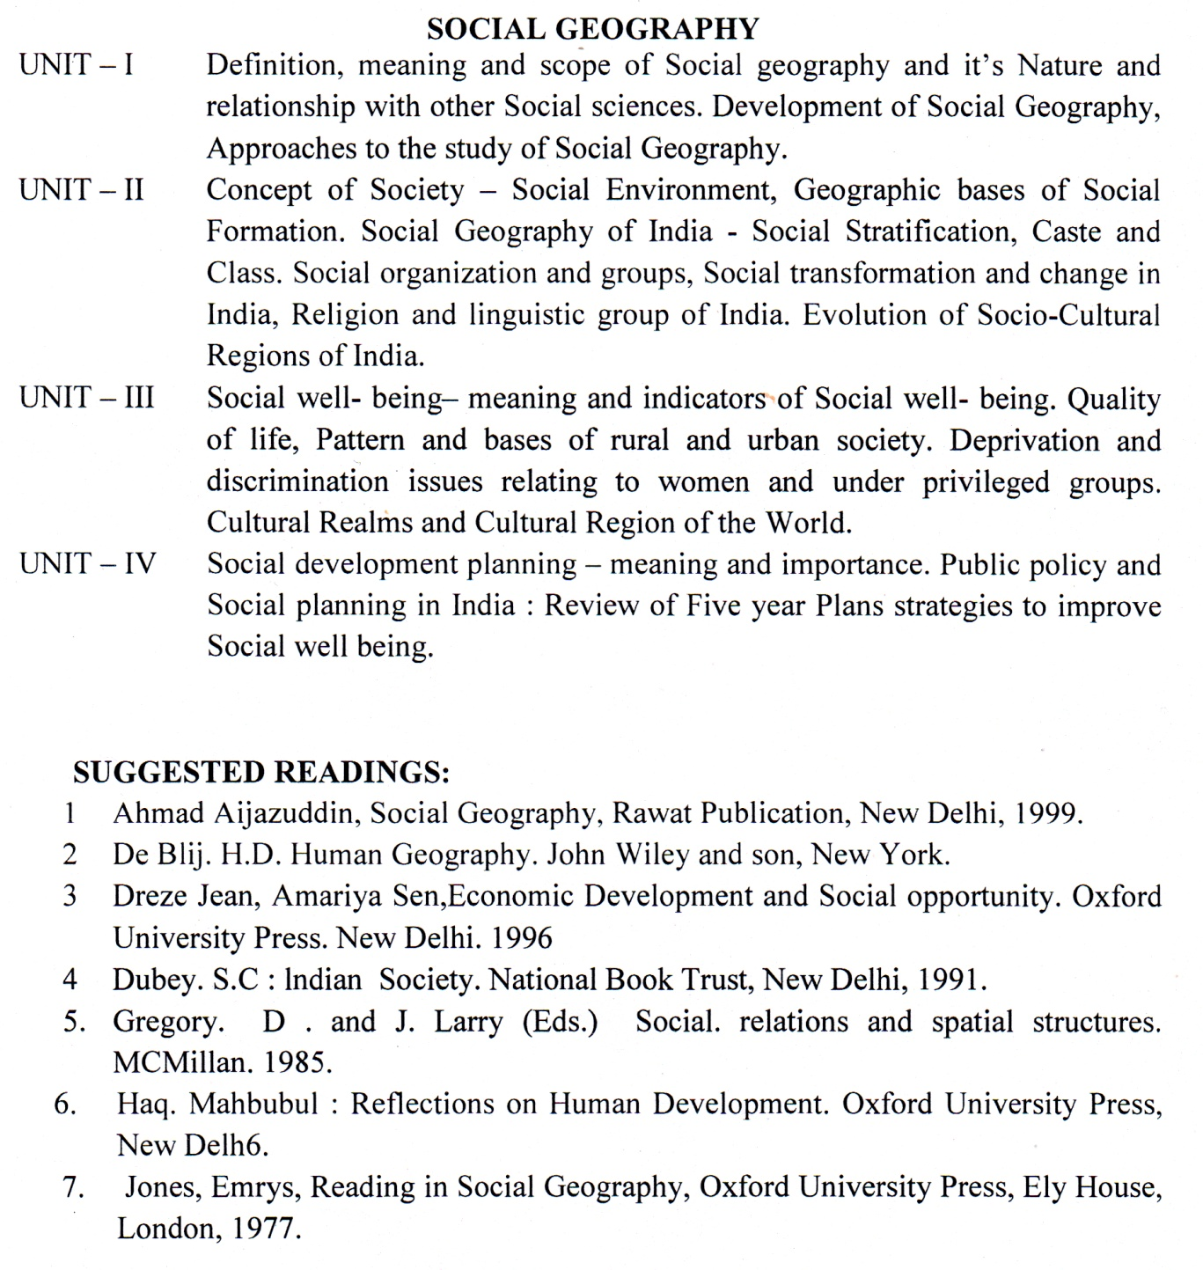
SEMESTER-II
paper - IIi
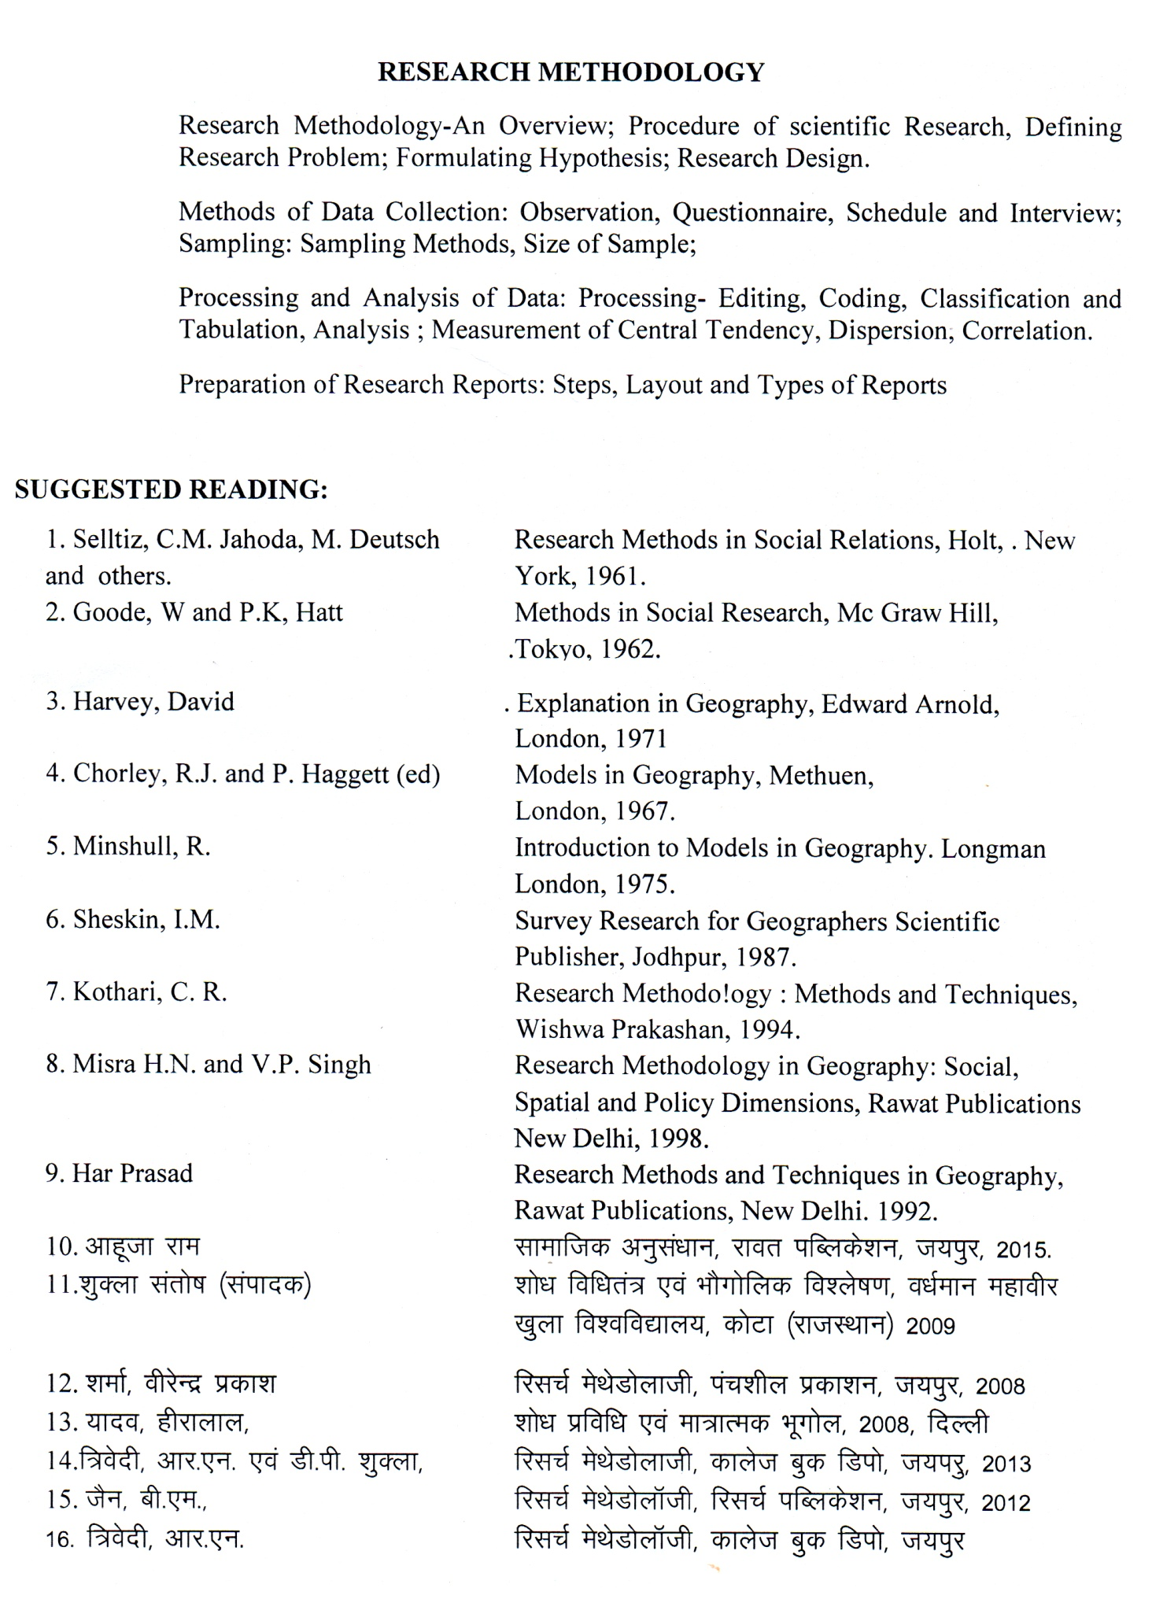
GEOGRAPHY OF CHHATTISGARH
paper – IV

OBJECTIVES :

The aim of the course is to give the knowledge to the student with meso micro region of the country. To prepare the student- for understanding the chhattisgarh region as a dynamic entity emerging from the interaction of the physical and regional structure over time.

COURSE CONTENT -
  - Detailed Study of Chhattisgarh :- Location, Extent, Geology, Physical Features, Climate, Drainage, Soil and Vegetation.
  - Socio-Economic Setting :- Land use and Agricultural Region, Irrigation, Major irrigation projects, Mineral and power resources.
  - Major industries :- Iron and Steel, Cement, Aluminum, Agro- Industries
  - Culture and Development - Distribution of population ,Socio. Cultural Characteristics of population.
  - Transport - Rail - Road and Air.
  - Trade and Tourism : Major tourist places and tourism possibilities.
  - Tribes of Chhattisgarh

SUGGESTED READINGS :-
1. Das, P. K. : The Monsoon. National Book Trust of India, New Delhi.
2. Government of India : The Gazetteer of India. Vol. 1 : The land and people. Publication Division, New Delhi.
3. Deshpande, C.D. : India- A Regional Interpretation. Northern Book Cetre, New Delhi.
4. Mukherjee, A. B. & A. Aijazuddin, eds. : India-Culture, Society & Economy. Inter India, New Delhi.
5. Sharma, T. C. & O. Countinho : Economic and Commercial Geography of India, Vikash Publication , New Delhi.
6. singh, Jagdish : India. Gyanodaya, Gorakhpur.
8. MkW- Ogh-ds- frokjh & NRrhlx<+ dk Hkwxksy
9. MkW- ,y-,u-oekZ & NRrhlx<+ dk Hkwxksy

SEMESTER – II
M.A. (Practical)
MIM. M. - 100
MIN. M. 36
Objectives
To familiarze how topographic, cadastral maps or plan of any area are prepared to enhance the skill of the students in the field of survey for revenue purposes and understanding the principals of map making.

Course Content:-
1. Assessment to land by using different techniques- Profiles-serial, composite, projected, superimposed profile.
Hypsometric curve, Altimetric curve, histogram, Slope Analysis-Wentworth & Smith
2. Climatic diagram :- Ergograph. Water balance graph Clinograph.
3. Map projection: - Construction of world map projection.

4. Thematic Mapping(Socio-Economic)
Socio-economic data sources and techniques of analysis of the socio- economic data through the preparation of single purpose. Choropleth, Isopleth, Dot Method
5. Geological Maps: Basic definition, Conformable and Unconformable series

SUGGESTED READINGS:-
1. Kanitkar: Surveying and levelling
2. Punmia: surveying
3. Mitra. R. P. and Ramesh A : Fundamentals of Cartography Revised Edition, concept Publication New Delhi.
4. Monkhouse-Maps and diagrams Methuen 1971.
5. Sandover, J. A. Plane Surveying. Arnold 1961.
6. Singh, R. L. and Dutt, P. K. Elements of Practical Geography Students Friends. Allahabad 1968.
7. ‘kekZ ts-ih- & izk;ksfxd Hkwxksy] jlrksxh ifCyds’ku esjBA
8. pkSgku] ih-vkj- % iz;ksxkRed Hkwxksy
9. ;kno] ghjkyky] izk;ksfxd Hkwxksy

--00—

M.A. GEOGRAPHY
SEMESTER - III
- The M.A. Semester - III examination in Geography shall consist of 500 Marks. There shall be four theory papers each of 100 marks and one practical of 100 Marks as follows :-

Paper | Title | External |  | Internal |  | Total
 |  | Mx. | Min. | Mx. | Min
I | Geography of Rural Settlement | 80 | 29 | 20 | 7 | 100
II | Geography of Resources | 80 | 29 | 20 | 7 | 100
III | Regional Planning & Development | 80 | 29 | 20 | 7 | 100
IV | Remote Sensing and GIS | 80 | 29 | 20 | 7 | 100
V | Practical – Socio Economics Survey Project Report and Excursion |  |  |  |  | 100

- The theory papers shall be of three hours duration.
- Candidate will be required to pass separately in theory and practical Examination.
- (a) In the practical examination the following shall be the allotment of time and marks.
Report Viva
(i) Project Report : 100 Marks – 70 + 30
(b) The external and internal examiner shall jointly submit marks.
(c) All the candidates shall present at the time of the practical examination. Their paractical record regularly signed by the teachers concerned.
(d) Candidate will be required 36% of marks to pass external and internal Examination separately.

SEMESTER – III (Geography)
GEOGRAPHY OF RURAL SETTLEMENT
paper - I

OBJECTIVES :
The objective of the course are to motivate the students :-
- To understand the growth and evolution of rural settlement,
- To recognise and analyse the distributions, patterns, morphology and functions of rural settlements.
- To analyse and suggest rural settlement planning in India.
- To examine the prevailing social and environmental issues in rural areas of India.

Course Contenets :-
- Nature, scope, significance and development of settlement Geography.
- Relationship of settlement Geography other social Science.
- Concept of settlement Geography.
- Meaning, origin, Evolution approaches of settlement.
- Types of Rural settlement.
- Rural morphology :- Cultural landscape, elements in rural settlement in different Geographical Environments with special reference to India.
- Rural House & their Types; field, patterns origin, evolution, size, social-spatial structure of Indian villages.
  - Size and spacing of Rural settlements.
  - Rural Houses and House Types, Rural Service Centre and their Identification
  - Rural problems and planning.

Suggested Readings :-
1. Rural settlements - A cultural Geographical analysis, inter India publication Delhi 1985.
2. Mitra, A. : Report on House Types and Village Settlement Patterns in India. Publication. New Delhi, 1985.
3. Rao, E. N. : Strategy for Integrated Rural Development B.R. Publication Cor., Delhi. 1986.

GEOGRAPHY OF RESOURCES

PAPER-II

M.M.-80
MIN.M. 29
Course Contenets:
Nature, scope and significance of Geography of Natural Resources.
Definition and concept of natural resources as related to cultural, economic and technological development stages and perceptions
Classification of natural resources according to renewability, increasability, availability and distribution conditions.
Characteristics and distribution pattern of major natural resources - soils, forests, minerals and water ; natural vegetation - biotic successions, major biotic regions of the world. Biomass,
Conservation and management of natural resources - concepts, methods and measures of conservation with reference to major natural resources. India’s national policy on natural resources, resource potential and future technology.
Resource region of the world and India.

Books Recommended

1. Ali, S.A. : Resources For Future Economic Growth, Vikas Publishing House Pvt. Ltd., New Delhi, 1979.
2. Duncan, G. : “ Resource Utilization and the Conservation Concept” in Readings in Economic Geography, New York, 1967.
3. Singh, K.N. and Singh, J. : Arthik Bhoogol Ke Multatva, Tara Press, Varanasi, 1982
4. Smith, G.H. (ed.): Conservation of Natural Resources, John wiley and sons, New York, 1950.
5. Stringer, E. and Davies, J.S.: Geography of Resources, Carsell, London, 1966.
6. Zimmerman, E.W.: World Resources and Industries, Harper, New York.

REGIONAL DEVELOPMENT AND PLANNING

PAPER-III

M.M.-80
MIN.M. 29

OBJECTIVES :
1. To understand and evaluate the concept of Regional Geography and its role in planning.
2. To identify the issues relating to the development of the region.
3. To identify the causes of regional disparities in development perspactive and policy improvement.

COURSE CONTAINTS.
Regional concept in Geography- Conceptual and theoretical frame work., Merits and limitation of application to regional planning and development.
Types of Region, Formal and Functional. Uniform and Nodal single purpose and composite. Region in the context of planning.
Special purpose Region- River valley Region, Metropolitan Region.
Problem Region; Hill Region, Tribal region, Regions of drought and Floods.
Planning Process- Sect oral Temporal and spatial Dimensions- Planning for a region’s development.
Decentralized planning process National State and District level planning process. Panchayati Raj system -role and importance in regional development.
Indicators of development measuring, Levels of regional development. Regional development in India. Problem and prospect.

Suggested Readings :-
1. Bhat, L.S. : Regional Planning in India, Statistical Publishing Society, Calcutta, 1973.
2. Bhat, L.S. et al. : Micro-Level Planning : A Case Study of Karnal Area, Haryana, K.B. Publications, New Delhi, 1976.
3. Glikson, Arthur : Regional Planning and Development – A Reader, M.I.T. Press, Cambridge, Mass, 1967.
4. Gosal, G.S. and Krishan, G. : Regional Disparities in Levels of Socio-Economic Development in Punjab, Vishal Publications. Kurukshetra, 1984.
5. Kundu, A and Raza, Moonis : Indian Economy – The Regional Dimension, Spectrum Publishers, New Delhi, 1982.

REMOTE SENSING TECHNIQUES

PAPER -IV

M.M.-80
MIN.M. 29
OBJECTIVES:
- To introduce to the students the basic principles of Remote Sensing;
- To indicate the methods of visual and digital interpretations of satellite imageries.
- To outline the application value of Remote sensing.

COURSE CONTENTS :
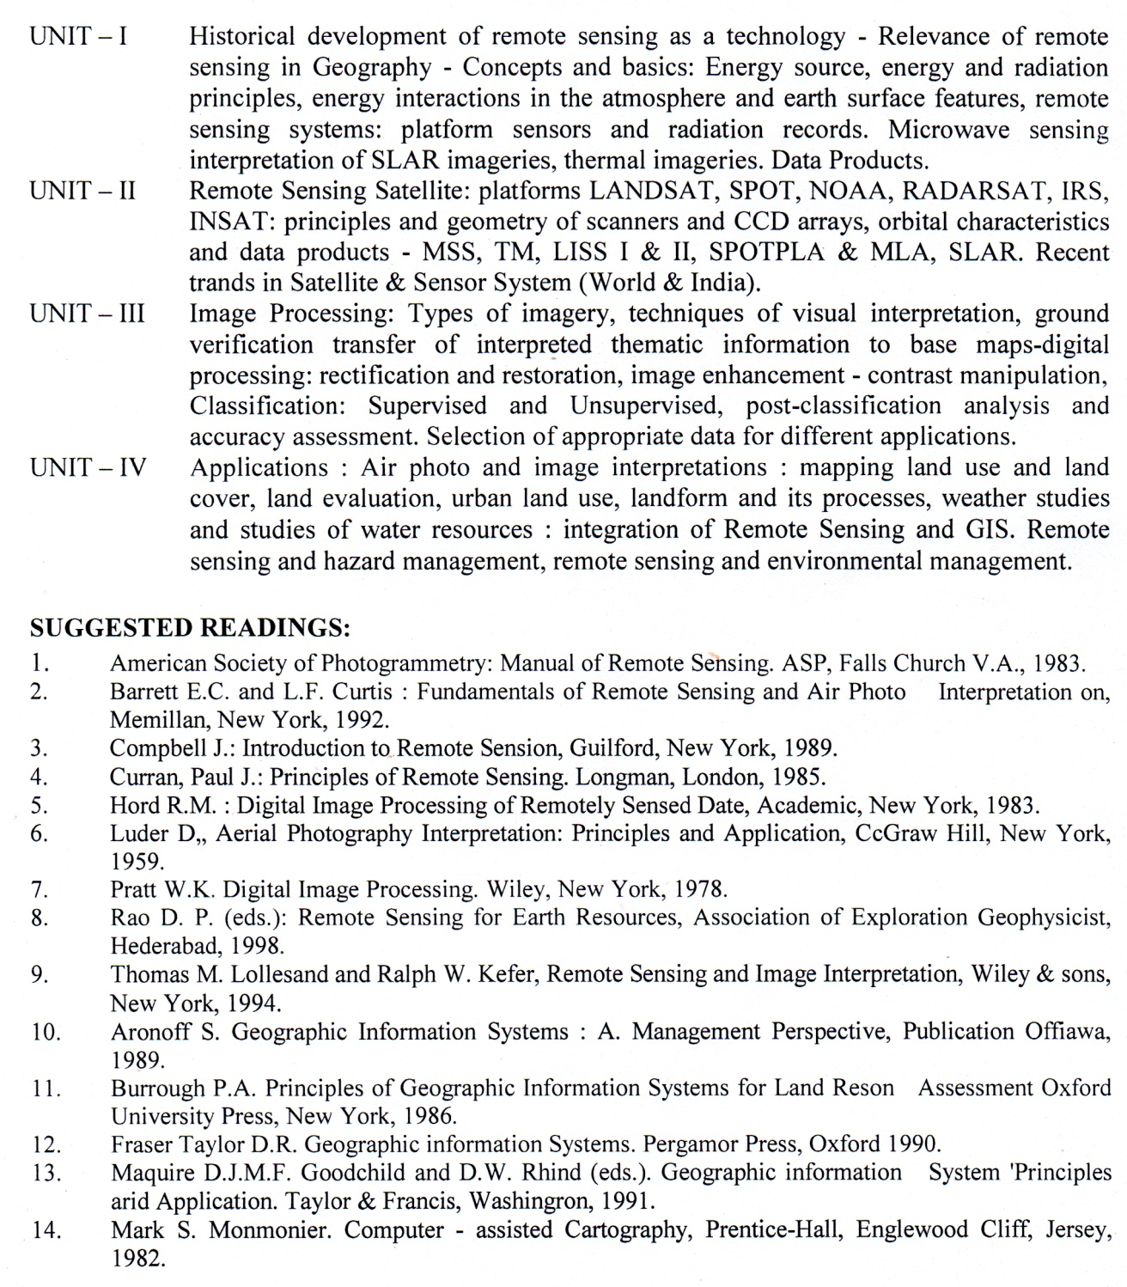
Semester -III
PRACTICAL (Project work)
Socio –Economic Survey report

OBJECTIVES-
Main objective of the field work is to provide the students with the understanding of ground reality of a chosen village/town by observation , mapping of land use, cropping pattern and conducted a socio-economics survey of the household with the help of questionnaire.

Course Contents :

1. Collect demographic social & economic data of the village/town from census reports to study the temporal changes.
2. Prepare a cadastral map of village/town.
3. Based on results of the land use and socio-economic survey of the household, prepare a critical field report, photographs, and sketches, in addition to maps and diagrams may supplement the report.

Selected Readings :
1. Monkhouse ,F.J. & Wilkinson : Maps and diagrams ,Methuen London
2. Singh , R.L. : Practical Geography
3. Kothari , C.R. : Reaserch Methodology
4. Sharma J.P. :Practical Geography
5. Yadav , Hiralal : Practical Geography

--00--

M.A. GEOGRAPHY
SEMESTER - IV
- The M.A. Semester - IV examination in Geography shall consist of 500 Marks. There shall be four theory papers each of 100 marks and one practical of 100 Marks as follows :-

Paper | Title | External |  | Internal |  | Total
 |  | Mx. | Min. | Mx. | Min
I | Population Geography | 80 | 29 | 20 | 7 | 100
II | Urban Geography | 80 | 29 | 20 | 7 | 100
III | Agricultural Geography | 80 | 29 | 20 | 7 | 100
IV | Geography of Tourism | 80 | 29 | 20 | 7 | 100
V | Practical - |  |  |  |  | 100

- The theory papers shall be of three hours duration.
- Candidate will be required to pass separately in theory and practical Examination.
- (a) In the practical examination the following shall be the allotment of time and marks.
Report Viva
(i) Lab Work : 80 Marks – 70 + 10
(ii) Excursion : 20 Marks – 10 + 10
(b) The external and internal examiner shall jointly submit marks.
(c) All the candidates shall present at the time of the practical examination. Project Report and Excursion report signed by the teachers concerned.
(d) Candidate will be required 36% of marks to pass external and internal Examination separately.

Semester -IV
POPULATION GEOGRAPHY
PAPER - I

M.M.-80
MIN.M. 29
OBJECTIVES :
To introduce the student to the complex dimensions of population and To provide the student an idea about settlement issues.

COURSE CONTENTS :

Population Geography – Definition and scope of population geography relation of population geography with other subjects of social sciences, Historical development of population geography in western countries and in the India , sources of population data, census and its history.
Distribution of Population - The concept of Population density and its types, factors affecting population distribution, population in the world with special reference to Europe and Asia, Distribution of Population in India.
Growth of Population :- Population Growth in India population theories – Malthusian theory & demography transition.
Population Composition :- In terms of age and sex, rural and Urban, educational status and occupational structure, significance of these elements in population analysis & factor affecting their composition in a population broad world patterns and detailed special patterns in India.
Population Dynamics – Measurements of fertility and mortality, migration – National & International patterns.
Population resources – Concept of optimum, over population, under population, population resources region, population region of India, population policy in India.

SUGGESTED READINGS :
1. Bogue, D.J. Principles in Demography. John Wiley, New York 1969.
2. Bose, Ashish et. al. : Population in India’s Development (1947-2000) Vikas Publishing House, New Delhi 1974.
3. Chandna, R.C. Geography of Population : Concept Determinants and patterns Kalyani Publishers, New York 2000
4. Clark. John I. Population Geography. Pergamon Press, Oxford 1973
5. Crook. Niget Principles of Population and Development Pergmon Press. New York 1997
6. Garnier, B.J. Geography of Population Longman, London 1970
7. mamoria, C.B. India’s Population : Kitab Mahal New Delhi 1981.
8. Sundaram K. V. and sudesh nangia, (ed.) Population Geograph. heritage. Publication, Delhi 1986
9. Woods, R. Population Analysis in Geography. London 1979.
10. Zelinsky Wilbur, A Prologue to Population Geography. Prentice Hall, 1966.
URBAN GEOGRAPHY

PAPER -II

M.M.-80
MIN.M. 29

OBJECTIVE

  - Understand the process of urbanization and origin, growth and classification of urban settlements with relevant theories and models;
  - Examine the changing economic base and structure of the contemporary cities;
  - Relate urbanization process and the evolution of urban system.
  - Examine the contemporary urban issues and suggest new urban planning and urban policy perspectives.

COURSE CONTENTS :
Nature and scope of urban Geography : Approaches and recent trends in Geography. Origin and growth of Urban Settlements. Ancient, Medieval and Modern Towns. World growth of Urbanisation. Urbanisation in India.
Size and distribution of Towns :- Rank size rule central place theory, Christaller and Losch. Urban heirarchy. Urban expansion - Basic and Non Basic Concept. The Urban- Rural Fring , Umland.
General nature of city structure : Centrifugal and centripetal Forces in Urban Geography. Theories of Urban Structure- Concentric zone theory ,Sector and Multicentred Theory.
General nature of city structure -Internal structure morphology - CBD. Urban Function and Functional Classification of TOWNS. C.D. Harris and J. Nelson. contribution of Indian Geographers.
Contemporary urban issues : Urban slum and environmental problems ,urban policy and planning in India. Green belts.Metropolitan planning.

Suggested Readings :
1. Alam, S.M. Hyderabad- Secunderabad Twin Cities Asta Publishing, Bombay 1964.
2. Berry, B.J.L. and Horton I.F. Geographic Perspective on Urban Systems, Prentice Hall, Englewood Cliffs, New Jersey, 1970.
3. Carter ; The Study of Urban Geography, Edward Arnold Publishers, London, 1972
4. Chorley, R.J.O. Haggestt P. (ed.) : Models in Geography, Methuen, London, 1966
5. Dickinson, R.E. City and Region, Routtedge, London, 1964.
6. Mumford, L: Culture of Cities, Mcmillan & Co. London 1958.
7. Mumford, L. culture of cities of Memillan & Co. London, 1958.
8. Rao V.L.S.P. Urbanisation in India : Spaial Dimensions, Concept Publishing Co. New Delhi Concept.
9. Singh K and Steirberg F. (eds.) : Urban India in Crisis, New Age interns, New Delhi. 1998.
10. Tewari, Vinod, Jay A. Welbstein, VLS Prakasa Rao (editors) Indian Cities Ecological Perspectives Concept 1986.

AGRICULTURAL GEOGRAPHY

PAPER -III

M.M.-80
MIN.M. 29
OBJECTIVE:
1. To familiarize the students with the concept, origin, and development of agriculture; to examine the role of agricultural determinants towards changing cropping patterns, intensity, productivity, diversification and specialization. The course further aims to familiarize the students with the application of various theories models and classification schemes of cropping patterns and productivity.
2. its objectives is also to discuss environmental, technological and social issues in agricultural sector with special reference to India.

COURSE CONTENTS:

Agricultural Geography : Nature, Scope, Significance and development. Approaches to the study of agricultural geography, Commodity, systematic and regional. Origin and dispersal of agriculture.

Determinants of agricultural land use : Physical economic, Social, and technological. Selected agricultural concepts and their measurements; Cropping pattern, Crop concentration, Intensity of cropping, degree of commercialization, Diversification and efficiency & productivity, Crop combination regions.

Theories of agricultural location based on several multi-dimensioned factors: Whittlesey’s Classification of agricultural regions.

Agricultural in India- Regional pattern of productivity in India. Green Revolution, White Revolution. Specific problems in Indian agriculture and their management and planning. Agricultural Policy in India.

Suggested Readings-
1. Gregor, H.P. : Geography of Agriculture. Prentice Hall, New York, 1970.
2. Morgan W.B. and Norton, R.J.C. : Agricultural Geography Methuen, London, 1971.
3. Morgan, W.B. : Agriculture in the Third World- World- A Spatial Analysis. West view Press, Boulder, 1978.
4. Singh, J. and Dhillon, S.S.: Agricultural Geography, Tata Mc Graw Hill Pub.; New Delhi,1988.
5. Tarrant, J.R. : Agricultural Geography. Wiley, New York, 1974.

GEOGRAPHY OF TOURISM

Paper -IV

M.M.-80
MIN.M.29
Objectives :
The objectives of this course are:
* to familiarize the students with aspects of tourism which have a bearing on subject matter of geography;
* to orient the students to the logistics of tourism industry and the role of tourism in regional development.
* to understand the impact of tourism on physical and human environments.

Course Contents:
Basic of tourism:, Definition & Importance of tourism; Factors
influencing tourism: historical natural, socio-cultural and economic motivating factors for pilgrimages: leisure, recreation; elements of tourism, tourism as an industry.
Geography of tourism:- its spatial affinity; areal and locational dimensions comprising physical, cultural, historical and economic,) Tourism types: cultural, eco-ethno-coastal and adventure tourism and international tourism; globalization and tourism.
Indian Tourism: regional dimensions tourism in chhattisgarh
Infrastructure and support system-accommodation and supplementary accommodation; other facilities and amenities;
Impacts of tourism: physical, economic, social, perceptional Environmental and Indian hotel industry. Impact of globalization on tourism.

Selected Readings –
1. Bhatia A. K. : Tourism Development : Principles and Practices. Sterling Publishers, New Delhi 1996
2. Bhatiya, A. K. Internationa Tourism- Foundamentals and Practices, Sterling, New Delhi, 1991
3. Hunter C and Green H: Tourism and the Environment: A Sustainable Relationship, routledge, London, 1995
4. Pearce D. G. Tourism To-day: A Geographical Analysis, Harlow, Longman,1987.
5. Voase R. : Tourism: The Human Perspective Hodder & Stoughton, London, 1995.

Semester -IV
M.A. (Geography)
PRACTICAL
OBJECTIVES-
To introduces some statistical procedures to the student to be applied to various themes in geography. To train the students & to handle these statistic for analyze the geographical problems.

Course Contents –
(a) Geography and statistics – Nature of Geographical Data Quantitative Revolution in Geography, Collection and Tabulation of Geographical data.
Sampling Techniques - Basic concept methods of sampling,
Measures of Central Tendencies - Mean, Median, Mode, measures of Deviation,
Correlation : - Spearman’s Rank Difference Correlation method, Correlation coefficient by method of Least squares, partial correlation multiple correlation, Regression .
Hypothesis Testing – Needs and types of hypothesis, Good ness of fit and significance and confidence level parametric and non- parametric procedure, confidence tables, Chi square test, T, test & F Test,

(b) Remote sensing: Introduction of remote sensing, Application of the technique and remote sensing imageries interpretation. Visual Methods – Landuse/Landcover Mapping. Use and Application of GPS.
(c) Geographical Tour Report. (Geographical Excursion).

Suggested Reading :-
1. Gregory, S. Statistical Methods and the Geographer in Geography. An Introduction, Clarendan Press, Oxford, 1974.
2 Johnston R. J., Multivariate Statistical Analysis in Geography, Longman, London. 1973.
3. Dr. Manjur Alam, Statistical methods in Geography.
4- MkW- Ogh-ds- JhOkkLro] lkaf[;dh; Hkwxksy ds fl)kar] olqU/kjk izdk’ku] xksj[kiqjA

