ANNUAL QUALITY ASSURANCE REPORT
(AQAR)
2015-16
Submitted to
NATIONAL ASSESSMENT & ACCREDITATION COUNCIL
Bangaluru 560072
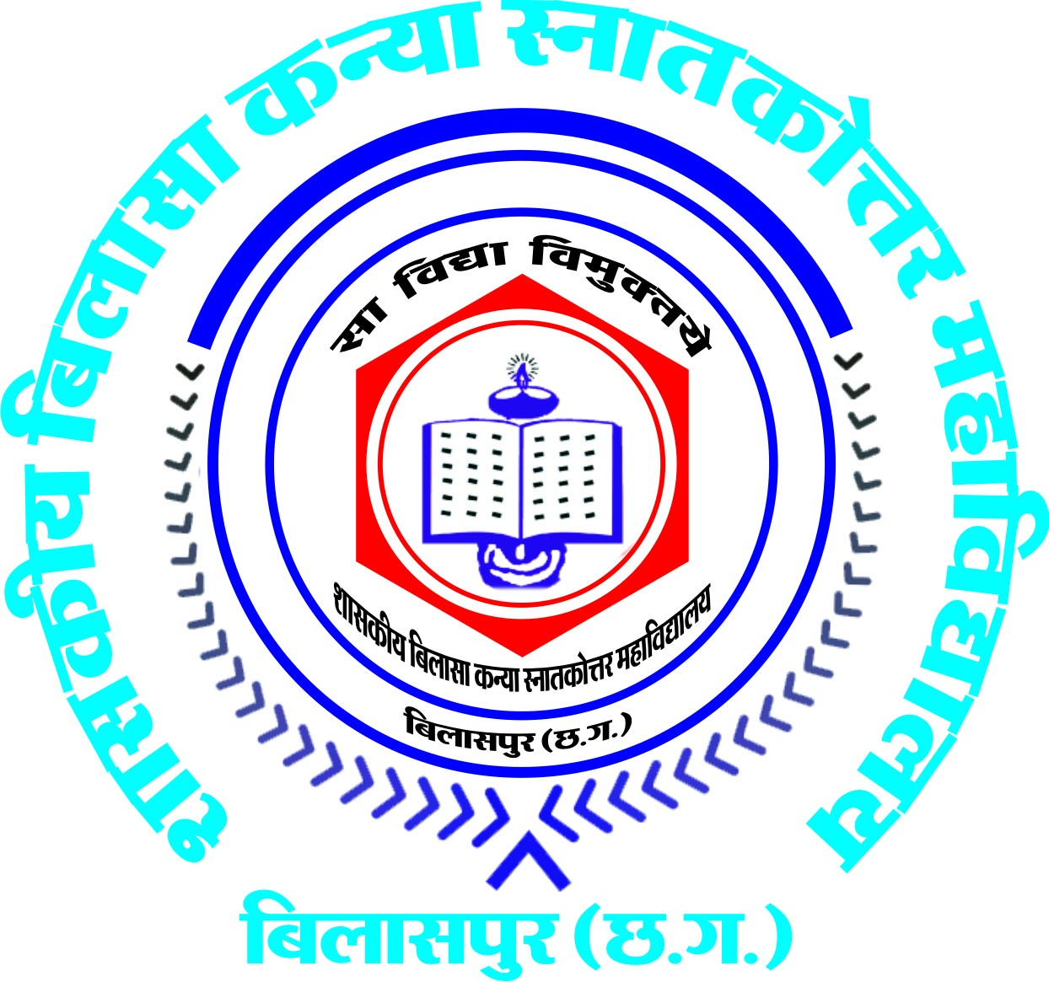

Submitted by
Govt. Bilasa Girls P.G.College Bilaspur (C.G.)
(Affiliated to Bilaspur University, Bilaspur)

Link Road, Bilaspur (C.G.) 495001
Tel. 07752-224249, 409952
Email: bilasagirlscollege_bilaspur@rediffmail.com
Website: http://bilasagirlscollege.ac.in
The Annual Quality Assurance Report (AQAR) of the IQAC

All NAAC accredited institutions will submit an annual self-reviewed progress report to NAAC, through its IQAC. The report is to detail the tangible results achieved in key areas, specifically identified by the institutional IQAC at the beginning of the academic year. The AQAR will detail the results of the perspective plan worked out by the IQAC. (Note: The AQAR period would be the Academic Year. For example, July 1, 2012 to June 30, 2013)

Part – A
1. Details of the Institution
Govt.Bilasa Girls P.G.College,Bilaspur(C.G.)
1.1 Name of the Institution
Link Road ,Bilaspur(C.G.)
1.2 Address Line 1

Address Line 2
Bilaspur
City/Town
Chhattisgarh
State
495001
Pin Code
Bilasagirlscollege_bilaspur@rediffmail.com
Institution e-mail address
07752-224249
Contact Nos.
Dr. S.L.Nirala
Name of the Head of the Institution:
07752-224249
Tel. No. with STD Code:

Mobile:
08839748096
Dr. Kaveri Dabhadker
Name of the IQAC Co-ordinator:
094241-45530
Mobile:
K_dab@rediffmail.com
IQAC e-mail address:
E&NER/BSM/2nd/CYCLE/CHCOGN12598/2013,27-11-2013
1.3 NAAC Track ID (For ex. MHCOGN 18879)-
http://bilasagirlscollege.ac.in
1.4 Website address:
http://bilasagirlscollege.ac.in/naac

Web-link of the AQAR:
For ex. http://www.ladykeanecollege.edu.in/AQAR201213.doc
1.5 Accreditation Details
Sl. No. | Cycle | Grade | CGPA | Year of Accreditation | Validity Period
1 | 1st Cycle | B++ | 81% | 2006 | 2011-12
2 | 2nd Cycle | A | 3.04 | 2014 | 2019
3 | 3rd Cycle
4 | 4th Cycle
S.NO.852-A/NAAC/IQAC/14-12-2009
1.6 Date of Establishment of IQAC: DD/MM/YYYY
2015-16
1.7 AQAR for the year (for example 2010-11)

1.8 Details of the previous year’s AQAR submitted to NAAC after the latest Assessment and Accreditation by NAAC ((for example AQAR 2010-11submitted to NAAC on 12-10-2011)
AQAR 2009-10_Submitted to NAAC on (5/10/2013)
AQAR_2010-11 Submitted to NAAC on (5/10/2013)
AQAR_2011-12 Submitted to NAAC on (5/10/2013)
AQAR_2012-13 Submitted to NAAC on (5/10/2013)
AFTER Reaccreditation (II Cycle)
AQAR_2013-14 Submitted to NAAC on (10/06/2014)
AQAR 2014-15 Submitted to NAAC on (12/7/2015)

1.9 Institutional Status
Submitted to NAAC on (5/10/2013)

√

University State Central Deemed Private
√

Affiliated College Yes No

√

Constituent College Yes No
√

Autonomous college of UGC Yes No

√

Regulatory Agency approved Institution Yes No
(eg. AICTE, BCI, MCI, PCI, NCI)

Type of Institution Co-education Men Women
√

√

Urban Rural Tribal

√

√

Financial Status Grant-in-aid UGC 2(f) UGC 12B
√

Grant-in-aid + Self Financing Totally Self-financing

1.10 Type of Faculty/Programme
Arts Science Commerce Law PEI (Phys Edu)
√

√

√

TEI (Edu) Engineering Health Science Management

Others (Specify)
PGDCA,DCA,Add-on courses,& BCA

1.11 Name of the Affiliating University (for the Colleges)
Bilaspur University, Bilaspur(C.G.)

1.12 Special status conferred by Central/ State Government-- UGC/CSIR/DST/DBT/ICMR etc
STATE
Autonomy by State/Central Govt. / University
UGC-CPE
University with Potential for Excellence UGC-CPE

DST Star Scheme UGC-CE

UGC-Special Assistance Programme DST-FIST

UGC-Innovative PG programmes Any other (Specify)

UGC-COP Programmes

2. IQAC Composition and Activities
2.1 No. of Teachers
8
2.2 No. of Administrative/Technical staff
0
1
2.3 No. of students
2.4 No. of Management representatives
01
1
2.5 No. of Alumni
1
2. 6 No. of any other stakeholder and
Community representatives
2.7 No. of Employers/ Industrialists
1
2.8 No. of other External Experts

2.9 Total No. of members
13
2.10 No. of IQAC meetings held
1
]’
loiouyr
2
01
2.11 No. of meetings with various stakeholders: No. Faculty
2
1
5
Non-Teaching Staff Students Alumni Others
√

2.12 Has IQAC received any funding from UGC during the year? Yes No
300000=00

If yes, mention the amount
2.13 Seminars and Conferences (only quality related)
(i) No. of Seminars/Conferences/ Workshops/Symposia organized by the IQAC
2LL

Y
Total Nos. International National State Institution Level
(ii) Themes
RUSA
Successful Women: Experience and Guidance

2.14 Significant Activities and contributions made by IQAC
Panchmukhi Yojna and Loksuraj Abhiyaan by the state government was started for the enhancement and up graduation of schools and colleges .Ranking of the college under Self –Assessment System successfully planned and fulfilled. In the above schemes colleges had been ranked on the basis of ten criteria i.e. cleanliness of the college (campus ,toilets), drinking water facility for the staff and the students, Wi-Fi connection, maintenance of the college building and gardens, office records (finance), academic work, NAAC assessment, campus placement, other activities (sport, library ,educational tours ,canteen etc). NAAC accreditation status carried twenty marks and other criteria had ten marks each. The college scored 95/100 and the college was awarded the best college in the state along with five other colleges . The principal of the college was given a certificate on 15th August 2016 as a mark of honour by the Chief Minister of C.G.

2.15 Plan of Action by IQAC/Outcome
The plan of action chalked out by the IQAC in the beginning of the year towards quality
Enhancement and the outcome achieved by the end of the year *
Plan of Action | Achievements
To provide drinking water facility in each wing  To organise a lecture by the doctors of various fields for students  To organise 7 days camp in village  To organise Guest lectures in various disciplines  Maintenance of college building & premises  Cultural and extracurricular activities | Completed  Organised under the banner of Red Cross Society.Dr. Sanjay Mehata Eye Specilist delivered lecture on “care for your valuable organ : EYE”  In the village Bodsara NSS Unit successfully organised the camp. Various activities-Social awareness programmes, haemoglobin test of women, environment awareness camp, yoga for children, village cleanliness services, cultural programme for villagers etc.  Guest lectures organised by the department of Maths, Chemistry, English, Urdu, Hindi, Geography, history.  Renovation of college building (construction of new class rooms, Toilets in hostel premises, Fencing of college garden, Guard room, CCTV in college premises, Sound system in girls common room)  Foundation Day celebration, Plantation Programme, Matdata Jagrukata hetu nukkad natak, ( Street – Play), rally, poster, and slogan competition, Annual sports, Annual cultural competitions, Annual gathering ,programs under departmental Associations
* Attach the Academic Calendar of the year as Annexure.( Annexure-I)

2.15 Whether the AQAR was placed in statutory body Yes No

Management Syndicate Any other body

Provide the details of the action taken
Looking upon the student strength and expansion of college building additional water coolers were installed .After the expansion of college building , the department of Political science , Music , Economics, History , Mathematics were reshuffled . Parking areas for the staff and students along with playground were renovated. Cleanliness of college building and the college premises was the first priority. More toilets were constructed. New classrooms are under construction.

Part – B
Criterion – I
1. Curricular Aspects

1.1 Details about Academic Programmes
Level of the Programme | Number of existing Programmes | Number of programmes added during the year | Number of self-financing programmes | Number of value added / Career Oriented programmes
PhD |  | 8
PG | 17 | - | 02
UG | 5 |  | 1
PG Diploma | 3 |  | 3
Advanced Diploma
Diploma | 1 |  | 1
Certificate | 8 |  | 8
Others |  |  |  | 6
Total | 34 | 8 | 15 | 6

Interdisciplinary | -
Innovative

1.2 (i) Flexibility of the Curriculum: CBCS/Core/Elective option / Open options
(ii) Pattern of programmes:
Pattern | Number of programmes
Semester | yes, at P.G. Level & U.G level
Trimester
Annual | B.Lib, PGDCA, DCA

Y
Y

Y
1.3 Feedback from stakeholders* Alumni Parents Employers Students
(On all aspects)

Y

Mode of feedback : Online Manual Co-operating schools (for PEI)
*Please provide an analysis of the feedback in the Annexure (Annexure- II)
1.4 Whether there is any revision/update of regulation or syllabi, if yes, mention their salient aspects.
Syllabi were revised accordingly. Single paper system in each subject is introduced as per university guidelines. Further, every year the syllabi for UG and PG courses are revised and if required minor or major changes are made.

1.5 Any new Department/Centre introduced during the year. If yes, give details.
NIL

Criterion – II
2. Teaching, Learning and Evaluation
2.1 Total No. of permanent faculty
Total | Asst. Professors | Associate Professors | Professors | Others
60 | 47 |  | 13

2.2 No. of permanent faculty with Ph.D.
53
2.3 No. of Faculty Positions Recruited (R) and Vacant (V) during the year
Asst. Professors |  | Associate Professors |  | Professors |  | Others |  | Total
R | V | R | V | R | V | R | V | R | V
 | 3 |  |  |  | 13 |  |  |  | 16

18

2.4 No. of Guest and Visiting faculty and Temporary faculty

2.5 Faculty participation in conferences and symposia:
No. of Faculty | International level | National level | State level
Attended Seminars/ Workshops | 6 | 24
Presented papers | 6 | 20
Resource Persons |  | 2

2.6 Innovative processes adopted by the institution in Teaching and Learning:
ICT based teaching, Interactive teaching adopted

205
2.7 Total No. of actual teaching days during this academic year

2.8 Examination/ Evaluation Reforms initiated by the Institution
Photocopy
(for example: Open Book Examination, Bar Coding,
Double Valuation, Photocopy, Online Multiple Choice Questions)

60

2.9 No. of faculty members involved in curriculum
restructuring/revision/syllabus development as
member of Board of Study/Faculty/Curriculum Development workshop-48
75%
2.10 Average percentage of attendance of students

2.11 Course/Programme wise distribution of pass percentage :
Title of the Programme | Total no. of students appeared | Division
Title of the Programme | Total no. of students appeared | Distinction % | I % | II % | III % | Pass %
UG (Final Year) | 595 |  | 46.97 | 44.01 | 1.4 | 92.3
PG(Final Year) | 249 |  | 80.32 | 18.07 | 0.8 | 99.8
2.12 How does IQAC Contribute/Monitor/Evaluate the Teaching & Learning processes:
Through Academic Audit, IQAC assess the academic performance of each department and the faculty against the set targets for the year. Convenor of Academic Audit Committee, review each department and offer suggestions for improvement.
2.13 Initiatives undertaken towards faculty development
Faculty / Staff Development Programmes | Number of faculty  benefitted
Refresher courses | 02
UGC – Faculty Improvement Programme
HRD programmes
Orientation programmes
Faculty exchange programme
Staff training conducted by the university | 20
Staff training conducted by college/ other institutions | 46
Summer / Winter schools, Workshops, etc. | 01
Others

2.14 Details of Administrative and Technical staff
Category | Number of Permanent  Employees | Number of Vacant  Positions | Number of permanent positions filled during the Year | Number of positions filled temporarily
Administrative Staff | 06 | 01 | NIL | NIL
Technical Staff | 19 | 02 | NIL | NIL

Criterion – III
3. Research, Consultancy and Extension
3.1 Initiatives of the IQAC in Sensitizing/Promoting Research Climate in the institution
To promote the research environment in the institution, Research facilities are provided by the college through enhancement of infrastructure facilities in the laboratories. Started Academic collaboration with CIMS Bilaspur, Coal Laboratory SECL Department of Geography, Rani Durgavati University .etc. Guest lectures are organised to exchange the knowledge with students & faculties both.

3.2 Details regarding major projects
 | Completed | Ongoing | Sanctioned | Submitted
Number | NIL | NIL | -NIL | -NIL
Outlay in Rs. Lakhs

3.3 Details regarding minor projects
 | Completed | Ongoing | Sanctioned | Submitted
Number | NIL | 11 | UGC | NIL
Outlay in Rs. Lakhs |  | 657000/-

3.4 Details on research publications
 | International | National | Others
Peer Review Journals | 2
Non-Peer Review Journals | 5 | 12
e-Journals | 02
Conference proceedings | 01 | 1

3.5 Details on Impact factor of publications:
1-222QQ33301
2

Range Average h-index Nos. in SCOPUS
3.6 Research funds sanctioned and received from various funding agencies, industry and other organisations
Nature of the Project | Duration  Year | Name of the  funding Agency | Total grant  sanctioned | Received
Major projects | nil | nil | nil | nil
Minor Projects | 11 | UGC
Interdisciplinary Projects | 1 | UGC | 60000/- | 45000/-
Industry sponsored | nil | nil | nil | nil
Projects sponsored by the University/ College | nil | nil | nil | nil
Students research projects
(other than compulsory by the University)
Any other(Specify)
Total | 12 | UGC | 60000 | 45000
3.7 No. of books published i) With ISBN No. 3 33 Chapters in Edited Books
4 NNNNDFFGDFG
NIL
NIL
ii) Without ISBN No.
3.8 No. of University Departments receiving funds from

UGC-SAP CAS DST-FIST

DPE DBT Scheme/funds
3.9 For colleges Autonomy CPE DBT Star Scheme
Y
Y

INSPIRE CE Any Other (specify)

Y
NIL
3.10 Revenue generated through consultancy

3.11 No. of conferences organized by the Institution
Level | International | National | State | University | College
Number | NIL | NIL | NIL | NIL | 02
Sponsoring agencies |  |  |  |  | College administration

3.12 No. of faculty served as experts, chairpersons or resource persons
04
NIL
NIL
3.13 No. of collaborations International National Any other
02
04
3.14 No. of linkages created during this year
3.15 Total budget for research for current year in lakhs :
NIL
NIL
From funding agency From Management of University/College
Total

3.16 No. of patents received this year

Type of Patent |  | Number
National | Applied | 01
National | Granted | NIL
International | Applied | NIL
International | Granted | NIL
Commercialised | Applied | NIL
Commercialised | Granted | NIL

3.17 No. of research awards/ recognitions received by faculty and research fellows
Of the institute in the year
Total | International | National | State | University | Dist | College
04 | NIL | 04 | NIL | NIL | NIL | NIL

3.18 No. of faculty from the Institution
10
Who are Ph.D. Guides
and students registered under them
40
03
3.19 No. of Ph.D. awarded by faculty from the Institution
3.20 No. of Research scholars receiving the Fellowships (Newly enrolled + existing ones)
NIL
NIL
JRF SRF Project Fellows Any other
NIL
NIL

3.21 No. of students Participated in NSS events:
01
08
90
NIL
University level State level National level International level

3.22 No. of students participated in NCC events:
40
6
7
NIL
University level State level National level International level
3.23 No. of Awards won in NSS:
NIL
NIL
NIL
01
University level State level National level International level

3.24 No. of Awards won in NCC:
NIL
NIL
NIL
NIL
University level State level National level International level
3.25 No. of Extension activities organized
NIL
05
University forum College forum
02
9

NCC NSS Any other

3.26 Major Activities during the year in the sphere of extension activities and Institutional Social Responsibility
7 Days Village camp In Village – Paad, Tahsil Takhatpur was organised. 90 Students from the college participated .During the camp various activities were performed as Morning procession, Yoga, Physical Training, Health awareness & Health Check-up, Sports & Cultural activities etc.
Mothers Meeting on child rearing practices and other problems regarding growth & development of the child was organised by the department of Home Science at Bhagini Mandal, Rajedra Nagar Bilaspur. PG students of the department visited old age homes to serve & make them aware regarding health & hygiene.
Department of geography visited to village Mohatara, Tendua, Kachar, to conduct socio-economic survey & environmental awareness.
Staff & students of the college participated in Voter awareness Rally and Street play was performed by the students of the college.
Criterion – IV
4. Infrastructure and Learning Resources
4.1 Details of increase in infrastructure facilities:
Facilities | Existing | Newly created | Source of Fund | Total
Campus area | 17acres | Nil | Nil | 17acres
Class rooms | 25 | 06 | CG GOVT. | 31
Laboratories | 10 | Nil | Nil | Nil
Seminar Halls | 01 | Nil | Nil | Nil
No. of important equipments purchased (≥ 1-0 lakh) during the current year. |  | Nil | Nil | Nil
Value of the equipment purchased during the year (Rs. in Lakhs) |  | Nil | Nil | Nil
Others | Nil | Nil |  | Nil

4.2 Computerization of administration and library
Computerization of Administrative work is in process.
Reading room is connected with internet facility.
Connectivity of E-Library is in process.

4.3 Library services:
 | Existing |  | Newly added |  | Total
 | No. | Value | No. | Value | No. | Value
Text Books | 49667 |  | 1238 | 411193
Reference Books | 1239
e-Books | Nil
Journals | 40 |  | NIL
e-Journals | Nil
Digital Database
CD & Video
Others (specify)

4.4 Technology up gradation (overall)
 | Total Computers | Computer Labs | Internet | Browsing Centres | Computer Centres | Office | Depart-ments | Others
Existing | 175 | 75 | YES |  | 39 | 3 | 58
Added | Nil | Nil | Nil | Nil | Nil | Nil | Nil
Total | 175 | 75 |  |  | 39 | 3 | 58

4.5 Computer, Internet access, training to teachers and students and any other programme for technology
Upgradation (Networking, e-Governance etc.)
Free internet facility through computers provided by computer nodal center of the college where student can learn the internet technology and computer under the guidance of instructor

4.6 Amount spent on maintenance in lakhs :
i) ICT
50000
2000000
ii) Campus Infrastructure and facilities
20000
iii) Equipments
50000
iv) Others
Total :
2120000
Criterion – V
5. Student Support and Progression
5.1 Contribution of IQAC in enhancing awareness about Student Support Services
For admission to various study programmes, advertisements, are issued in leading dailies regarding the programmes of study offered in various Departments at least two months before the commencement of the academic year.

5.2 Efforts made by the institution for tracking the progression
College takes keen interest in personality development of students and to achieve this goal efforts made by the college in this year are: - , Voters awareness Rally, Guest lectures etc.

ICT based teaching & availability of free internet facility makes the students more technocrats to gain the knowledge

5.3 (a) Total Number of students
UG | PG | Ph. D. | Others
2657 | 661 | 49 | 140

06
(b) No. of students outside the state
Nil
(c) No. of international students
No | %
No | %
 | 100
Men Women
Last Year |  |  |  |  |  | This Year
Gen | SC | ST | OBC | Physically Challenged | Total | General | SC | ST | OBC | Physically Challenged | Total
836 | 569 | 482 | 1185 | 12 | 3072 | 801 | 682 | 489 | 1346 |  | 3318

Demand ratio 1.44 Dropout % 2
5.4 Details of student support mechanism for coaching for competitive examinations (If any)
Faculty provide reading materials along with suggestions & guidance to the student.
Prepare them to face the interview, motivate them through group discussion etc.

500
No. of students beneficiaries
5.5 No. of students qualified in these examinations
NIL
NIL
NIL

NET SET/SLET GATE CAT
IAS/IPS etc State PSC UPSC Others
NIL

NIL

25
5.6 Details of student counselling and career guidance
Various programs were organised in the college by placement cell, to provide guidance and opportunities to the student in promotion of their carrier. Since most of the departments in the college motivate their students towards research, a majority of the student who completed their PG studies take up a research career after their programme of study. To facilitate this, the students obtain proper guidance during the final year of their studies from their respective project supervisors. Student who are interested in pursuing higher studies other than research, are guided by the faculty in the department.
Induction programme was organised by the C&G Cell for the first year student to provide information regarding academic, infrastructure, co-curricular activities of the college. Head of concerning departments addressed the students.
Guest lecture on research methodology was organised by the cell .Dr. S.K.Sharma ,a eminent geographer delivered the lecture.

No. of students benefited
500
5.7 Details of campus placement
On campus |  |  | Off Campus
Number of Organizations Visited | Number of Students Participated | Number of Students Placed | Number of Students Placed
3 | 300 | 15 | 35

5.8 Details of gender sensitization programmes
Institution is already following the VISHAKHA GUIDELINES for gender sensitization. There is no such problem faced by the institution till date .

5.9 Students Activities
5.9.1 No. of students participated in Sports, Games and other events
31
23
Nil
State/ University level National level International level
No. of students participated in cultural events
12
12
Nil
State/ University level National level International level
5.9.2 No. of medals /awards won by students in Sports, Games and other events
NIL
NIL
10
Sports: State/ University level National level International level
8
3
NIL
Cultural: State/ University level National level International level
5.10 Scholarships and Financial Support
 | Number of  students | Amount
Financial support from institution | 08 | 26000
Financial support from government | 688 | 3475447
Financial support from other sources | NIL | NIL
Number of students who received International/ National recognitions | NIL | NIL

5.11 Student organised / initiatives
NIL
NIL

NIL

Fairs : State/ University level National level International level
NIL

NIL

NIL

Exhibition: State/ University level National level International level
5.12 No. of social initiatives undertaken by the students
8
5.13 Major grievances of students (if any) redressed: _______NIL_______________________________
Criterion – VI
6. Governance, Leadership and Management
6.1 State the Vision and Mission of the institution

VISION: “Saa Vidya Yaa Vimuktaye” .
To make efforts to liberate & empowered young women of the region by imparting knowledge.
MISSION:
To create a healthy academic atmosphere in the region.
To promote quality education.
To educate girls student and to uplift them financially, socially and culturally
To conduct research and training programmes in various fields.
Make efforts for overall personality development of the students.

6.2 Does the Institution has a management Information System
Yes, we have the participative management information system. Principal plays a leading role in governance of the college. He constitutes different committees involving the staff member for the proper execution of college development plans and the information is provided to all.

6.3 Quality improvement strategies adopted by the institution for each of the following:
6.3.1 Curriculum Development
Curriculum design is based on UGC model.
Modifications are made to incorporate the regional needs based on feed back taken from stake holders, to prepare the students for Job opportunities, competitive exams, and research.

6.3.2 Teaching and Learning
Institution follows the conventional as well as modern methods.
To evaluate the teaching quality academic audit committee is formed.
Interactive sessions are held in the respective departments for the exposure of the students.
Learning based on outreach programme is also commenced.

6.3.3 Examination and Evaluation
Semester (PG) and Annual (UG) examination system are followed. Evaluation is on the basis of internal and external examination in the ratio of 20:80. Internal assessment includes Seminars, Project work, Viva-voce, unit test.
Continuous assessment system is adopted.

6.3.4 Research and Development
Faculty members pursue research activities on their own initiative.
Faculties are encouraged to prepare and submit the minor & major research projects to funding agencies like UGC, CGCOST etc.
College provide facilities with well equipped laboratories, books, journals to the faculties and scholars.
With prier permission faculties are also collaborate with national level labs& institute to pursue their research work.

6.3.5 Library, ICT and physical infrastructure / instrumentation
Automation of Library & inflibnet is in progress.
Audio-lab has been installed in reading room.
Teaching in Smart class room has started.
Free internet facilities are provided in the institution for the reference of reading material.
Due to increase in the strength of students and as per the requirements, Physical infrastructure extension is made.

6.3.6 Human Resource Management
Institution has provision to support the faculties and students in various ways- by organising seminars, by motivating teachers to attend seminars, Conferences, guest lecturers etc. by encouraging the faculty to publish research work and to take up project work.

6.3.7 Faculty and Staff recruitment
Faculty and staff recruitment is as per the govt. rules by the Chhattisgarh govt.
Janbhagidari Samiti recruits the temporary faculty and staff under the Self finance scheme.

6.3.8 Industry Interaction / Collaboration
For the enhancement of the quality of research and skill development institute has collaborated with other reputed institutes like: CMPDI, Bilaspur, , Student of chemistry department visited to industrial sector nearby bilaspur city

6.3.9 Admission of Students
Institution follows Chhattisgarh govt. rules.

6.4 Welfare schemes for
Teaching | As per Govt rule
Non teaching | As per Govt. rule
Students | Provision of Scholarship to SC, ST, OBC, Poor students

6.5 Total corpus fund generated Nil
6.6 Whether annual financial audit has been done Yes No

NO
6.7 Whether Academic and Administrative Audit (AAA) have been done?
Audit Type | External |  | Internal
Audit Type | Yes/No | Agency | Yes/No | Authority
Academic | NO |  | YES | AAC
Administrative | YES | GOVT. | NO

6.8 Does the University/ Autonomous College declare results within 30 days?
y
For UG Programmes Yes No

y
For PG Programmes Yes No

6.9 What efforts are made by the University/ Autonomous College for Examination Reforms?
The efforts made by the college for examination reforms are-
For smooth running of semester system guidelines were formed.
This year we introduced online submission of examination form.

Continuous assessment of students is made through tests, seminar, & examination.
Formation of various committees for smooth running of examination works.
Preparation of examination calendar in the beginning of the session

6.10 What efforts are made by the University to promote autonomy in the affiliated/constituent colleges?
University administration gives liberty to prepare our own syllabi.
Guidance & Support has been given by the University in nominating the members in various academic bodies, Counter signature of results, enhancement of Research activities, forwarding of college development Plans to UGC/RUSA etc.

6.11 Activities and support from the Alumni Association
Meeting of alumni association was held in the college .Suggestions by the members of the association are invited and considered.
One day lecture program is organised by the alumani on international women day.
As the member of IQAC/AC/BOS alumani took part in various activities of the college.

6.12 Activities and support from the Parent – Teacher Association
In the academic year 2015-16 parent –teacher meeting was organized by the college in the month of January.It gives an opportunity to the teacher to meet the parents of their ward.Feedback & tips derived from this meeting helps in the working of the college.
Suggestions and problems are discussed which helps in the improvement of academic and overall environment of the college.

6.13 Development programmes for support staff
NIL
6.14 Initiatives taken by the institution to make the campus eco-friendly
To make campus eco-friendly following steps have been taken by the college authority:
- Environment committee was formed to monitor the college green belt (Botanical Garden, Front garden, Hostel garden)
- Use of plastic is totally banned in college premises.
- Plantation programme organized in the month of July.
- Sokta Gudda was constructed to recharge the ground water.

Criterion – VII
7. Innovations and Best Practices
7.1 Innovations introduced during this academic year which have created a positive impact on the
functioning of the institution. Give details.
Induction programme for freshers students was organised to give detail information regarding courses, examination rules, cultural activities ,sports, NCC ,NSS Facilities and premises.
Taking inspiration from PM SWACHATA ABHIYAN , college was divided in to Six Zones, Each Zone is monitored by the group of teachers and students to keep it clean. Similarly forth class staff was also assigned specific area to clean for maintaining cleanliness of the college campus.

7.2 Provide the Action Taken Report (ATR) based on the plan of action decided upon at the beginning of the year
ATR is as per the annual reports:
Drinking water facility in the college premises in each wing is completed.
In village Bodsara NSS unit of the college successfully organised the camp. Various activities –social awareness programmes, environment awareness camp, yoga for children ,village cleanliness services, cultural programme for villagers.
Guest lecture organised by the department of Geography, Maths, English, Chemistry.
Renovation of the college building (construction of new class rooms, Toilets in hostel premises, fencing of the college garden, Guard room, CCTV in college premises, Sound system in girls common room)
Foundation day celebration, Plantation in the month of July, Matdata Jagrukta hetu NUUKAD NATAK etc. Was organised.
College magazine “ABHIVYAKTI” PUBLISHED.
EXAMINATION/STUDENT SEMINAR/Projects completed in stipulated time.
Feedback of randomly selected 50 students from each UG faculty and PG students has been taken. Feedback from alumni and parents were also taken

7.3 Give two Best Practices of the institution (please see the format in the NAAC Self-study Manuals)
Induction Programme from fresher’s
Clean Campus

*Provide the details in annexure (annexure need to be numbered as i, ii,iii)
7.4 Contribution to environmental awareness / protection
Tree Plantation was done in college premises as well as in rural sectors (Paad village) of the region.
Environmental awareness campaign was organised in villages – Kachar, Mohtara.

7.5 Whether environmental audit was conducted? Yes No

No

7.6 Any other relevant information the institution wishes to add. (for example SWOT Analysis)
nil

8. Plans of institution for next year

Infrastructure
Construction of Ramps for easy moving –facility for disable students as possible .
We will convert some class rooms as virtual classrooms. Provision of security cameras in every class room is in our future plan.
We have 9 labs, separate for UG and PG, well equipped with all safety measures. With approx total space of 10800 square feet. Soon we will create facilities for virtual dissections in Zoology and Virtual demonstrations in Clinical biochemistry lab. Remote sensing Lab related with Geography dept. is our future plan of infrastructural development.
Fully Automation of our library is in our future planning. Also inclusion of college in N-list is our prime plan.
Academic Quality
Create some more Inter and Trans –disciplinary courses
The laboratories of the Science Stream have been upgraded.
We are committing to make academic audit committee more effective, with result –giving academic and examination reforms.
We are opting semester-system in under-graduation level from the coming academic session, thus some effective examination reforms will be opted in the coming session.
Expansion of ICT based teaching facility in all departments and library.
Vigorous training for competitive exams.
Establishment of Virtual Laboratories in Zoology for dissections
Academic linkages will be developed with eminent institutes. .
Small workshops /conferences will be organized by the departments –that will be of inter-departmental pattern –by resource mobilization and knowledge transfer we will up grade knowledge level in horizontal level of our students.
Proposal for a course in MSW.


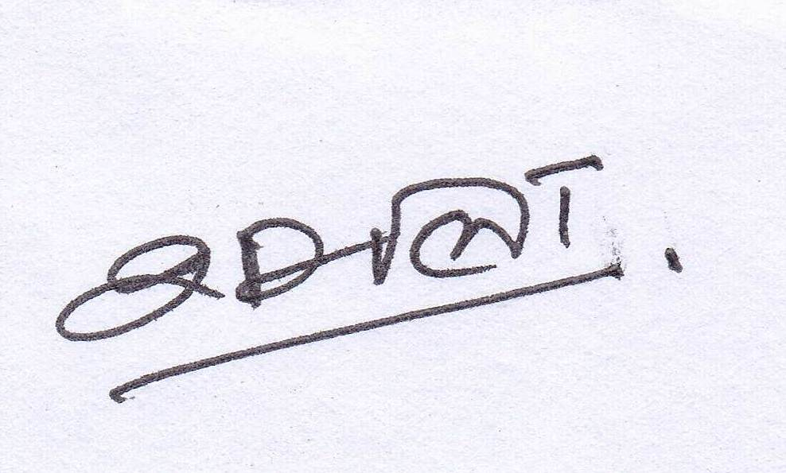

Name __Dr. K. Dabhadker Name Dr. S.L. NIRALA
_______________________________ _______________________________
Signature of the Coordinator, IQAC Signature of the Chairperson, IQAC

Annexure I
Abbreviations:
CAS - Career Advanced Scheme
CAT - Common Admission Test
CBCS - Choice Based Credit System
CE - Centre for Excellence
COP - Career Oriented Programme
CPE - College with Potential for Excellence
DPE - Department with Potential for Excellence
GATE - Graduate Aptitude Test
NET - National Eligibility Test
PEI - Physical Education Institution
SAP - Special Assistance Programme
SF - Self Financing
SLET - State Level Eligibility Test
TEI - Teacher Education Institution
UPE - University with Potential Excellence
UPSC - Union Public Service Commission

***************

Annexure II
Govt. Bilasa Girls’ P.G. College Bilaspur (C.G.)
Analysis of Questionnaire No-1
Under Graduate- year 2015-16
Questionnaires for Feedback from Students: Course evaluation
Very Good Good Satisfactory Less Satisfactory
S.No | Question | Graphical analysis of student’s feed back
1 | Depth of the course content including project work if any | 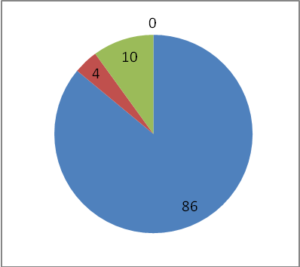
2 | Extent of coverage of course | 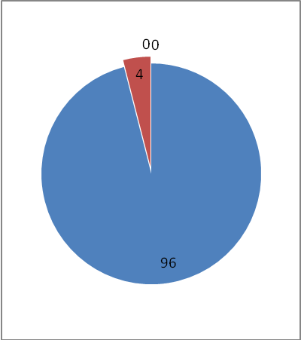
3 | Applicability/relevance to real life situations | 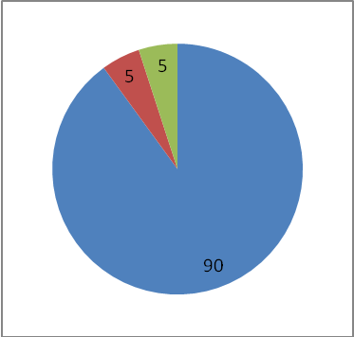
4 | Learning value (in terms of  knowledge, concepts, manual skills, analytical abilities and  broadening perspectives) | 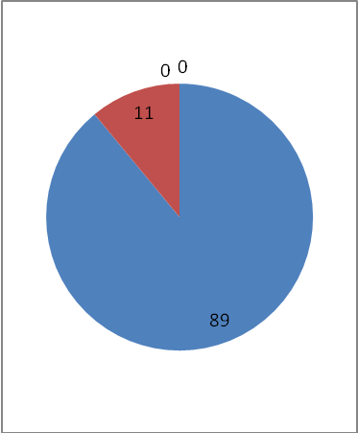
5 | Clarity and relevance of textual reading material | 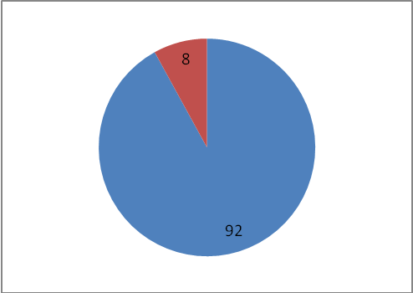
6 | Relevance of additional source material (Library) | 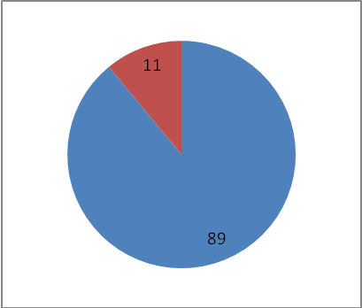
7 | Extent of effort required by students | 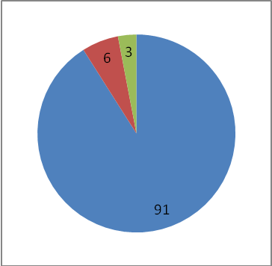
8 | Overall rating | 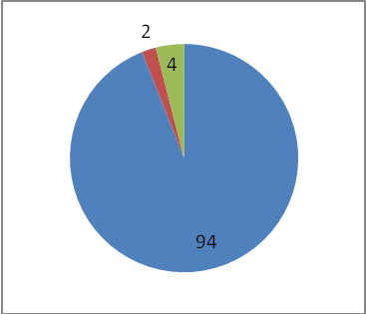

Analysis of Questionnaire No-3(2015-16)
Student’s Overall evaluation of Programme and teaching

S.No | CLARITY , RELEVENCE & SOURCES OF READING MATERIAL
 | 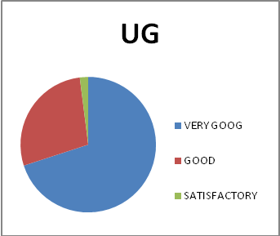 | 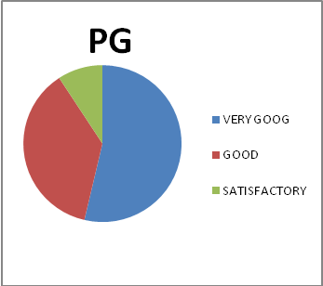
2 | sources of reading material
 | 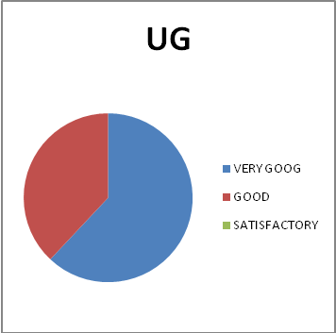 | 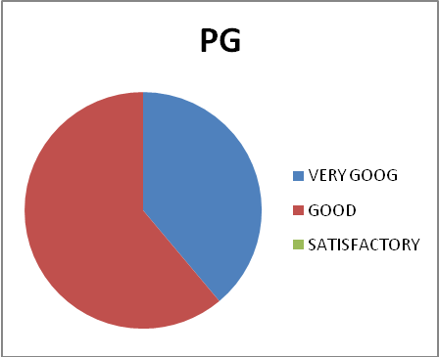
4 | DEAPTH OF THE COURSE CONTENT EXTENT & RELEVENCE
 | 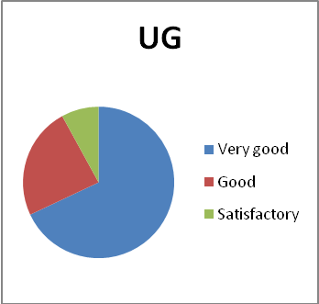 | 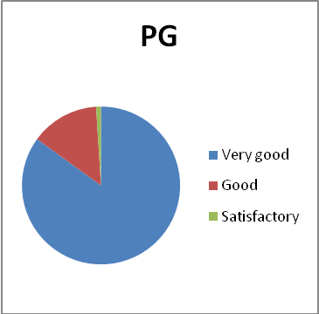
 | syllabus
 | 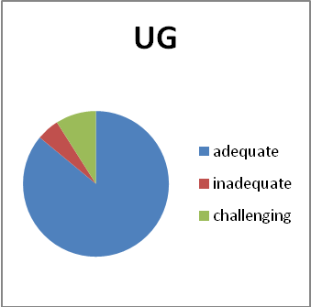 | 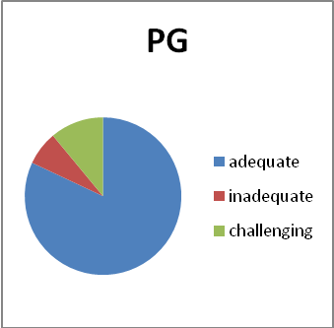
 | understanding of syllabus
 | 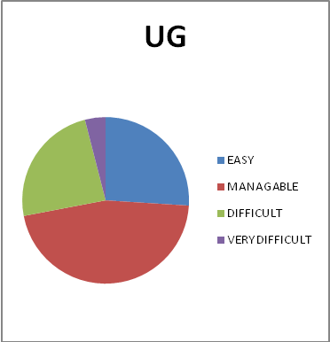 | 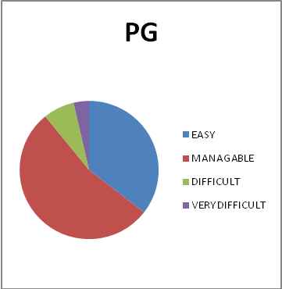
 | TEACHERS BEHAIVOUR
 | 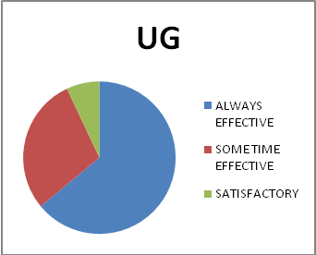 | 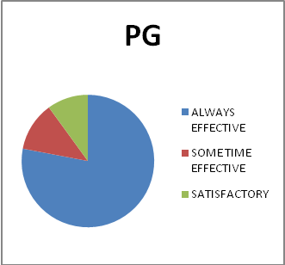

Dr Kaveri Dabhadkar Dr. S. L. NIRALA
Signature of Signature of
IQAC Convener Principal

BEST PRACTICE I
Annual Function
Context:
Annual function is the most awaited event of the student. It is the time when student explore themselves through various intellectual, cultural, sports, and other events organized during this festival. After a hectic schedule of teaching, examination such function creates the pleasant environment which is the best way to rejuvenate both student and teacher. These activities not only helpful to enhance the confidence in personality but also spawn a new talent that ultimately represent the college at state and national level.
Process:
In the month of july-august a meeting was organized (amalgamation ,IQAC, Student union committee).Following the academic calendar of the state government, this event is generally organize in last week of December..In charge of student union is the convener of this function. This celebration has three dimensions
1 Annual sports day : in this, traditional classical and modern games were played Both teachers and students took part.Rassi daud, chammch daud, musical chair along with football , volleyball , chess , badminton , Tennis ball etc are some of them . Student verses teacher competition is the most enjoyable event of this sports day.
2. Intellectual, literary and other compititions were orgaised in second day of this function.( Mehendi , Debate , Eassay , Best From Waste, Flower Decoration , Rangoli Etc.)
3. Thirs day is the cultural event day. colorful dances, plays , fancy dress singing competition is the main part of this function . Huge gathering of students, their participation make it joyful. Principal and other dignitaries express their blessingsto students.Union in-charge present the annual Progress Report of the college.
4. Best cultural program were selected for the very last day of this function when students were performed their art form in the presence of invited dignitaries of the various fields of society.
Winners of all the competitions are honored by MADELS and certificates on Prize distribution ceremony.

Obstacles
Accept some unavoidable conditions such as National issue, disturbance of examination schedule, natural calamities, circumstances of the college; it is celebrate every year in college.
Due to semester examination schedule in the month of December, participation of students in various events affected.
Now a days, with the use of high technology like smart mobile, internet etc .creativity among the youth decreases day by day .
Some of the student cannot take part in competition because after semester examination schedule most of the students came from remote area did not come to college.

BEST PRACTICE II
Empowerment of Women
Context
Empowerment of the women is a burning question of the society. Mission of the college is To promote the education to girl students coming from of backward areas of society as well as rural sector for their personality development and make them economically independent .Logo of the college “SA VIDYA YA VIMUKTAYE “ has the perception of women liberation by making them sound by all means of empowerment. College administration is always made affords in this direction so that More and more girls be able to take education, enhance the employability of the courses, academic, cultural, moral, mental development of students. There are plenty of activities are organized by the college throughout the year to achieve the goal of empowerment of students .Students participation is equally remarkable
Process
For Intellectual, cultural , and to improve the employability of courses, College administration organizes various activities besides basic class room teaching .
Intellectual:
Guest lecture: every academic session guest lectures were organized by various departments that not only helps to get knowledge but also has opportunities of interaction with subject experts.
Motivational lecture : To improve the thought process motivational lectures of dignitaries of the society were organized by career counseling cell of the college .
Celebration of women’s day is a big event of the college, delivered lectures and discussions create a new breathe of personality development.
Cultural
intact with the regional rituals and art form is a cultural empowerment. In college various function organized by the students and management .this practice emotionally involved the students with their culture and tradition which is the key of conservation of civilization .some of these are as fallows :
- Sarswati Pooja
- Welcome-Farewell ceremony
- Rangoli-Alpana competition
- Hair dressing, flower decoration, Pooja thali sajao, Salad decoration
- Folk dance and song competition
- Under the banner of SPICMAY Indian classical dances and music programme with lecture and demonstration.
- Teachers Day celebration
Economic :
To provide the way of economic empowerment, so many job oriented programs run in the college:
Skill based programme : speaking in English , Fundamentals of computer, Translation proficiency, Bakery, Tally
ROJGAR MULAK PATHYAKRAM : Clinical pathology, Fashion designing, Industrial chemistry, Biotechnology , PGDCA , BCA, DCA, B.lib I.sc.
Trainings : Toys making , artificial jewelry making , beauty parlor , Bag making ,Silai prashikshan , YOGA training, Sports training
Free Training Of Competitive Exams.
Regular information of various training programs , guest lectures organized by placement cell , placement programme by various companies, MYSY scheme of CG govt.
Obstacles:
Although so many affords has been made by the college administration for the development of employability & capacity of the students but still facing problems in many ways that are as fallows:
- Extensive schedule of examination both internal, semesters.
- Lack of enthusiasm among students
- Less Proficiency in English language.
- Emphasis has been given to classroom teaching more than other training by the Students.
- Poor student sometimes not be able to pay nominal charges for training

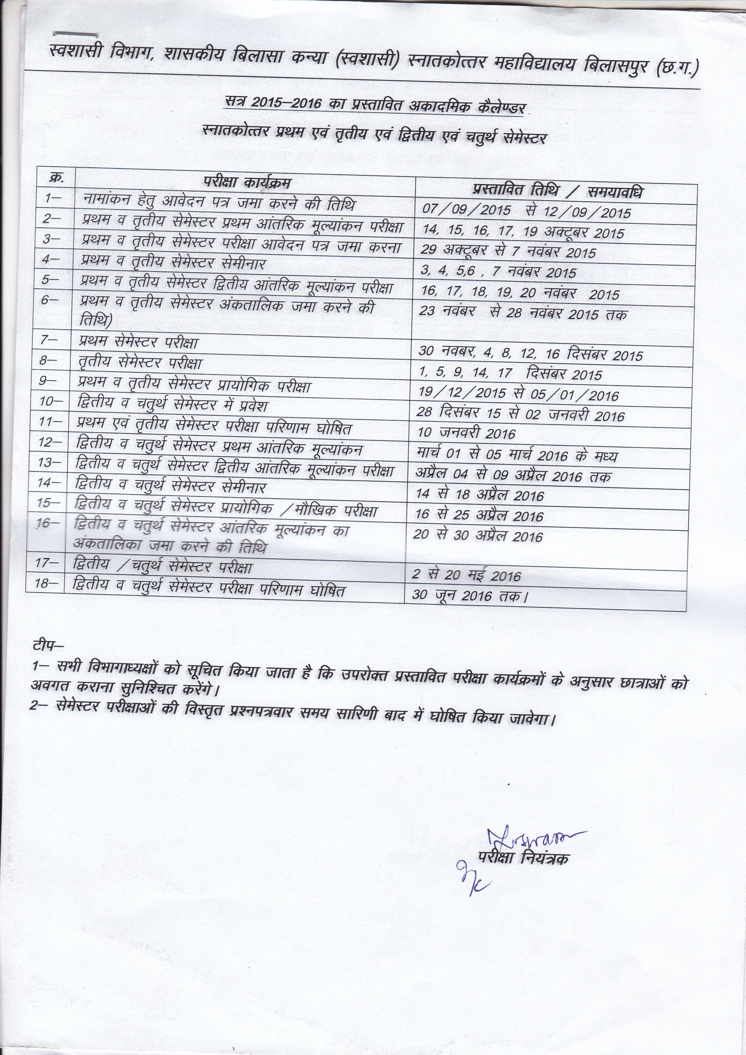

 | RESULTS 2015-2016
TITLE OF THE PROGRAMME | TOTAL APPEARED | DIV I | DIV II | DIV III | PASS%
B.A.VITH SEMESTER | 190 | 69 | 99 | 2 | 89
B.COM.PLAIN VITH SEM | 125 | 41 | 39 | 5 | 68
B.SC.(BIO) | 145 | 98 | 34 | 10 | 91
B.HSC. | 25 | 14 | 10 |  | 96
B.LIB. | 25 | 17 | 9 |  | 100
D.C.A. | 11 | 1 | 5 | 5 | 100
B.C.A. | 7 | 3 | 2 |  | 57
B.BOM.COMP | 24 | 14 | 7 |  | 68
BSC HOME SCIENCE (H) | 1 | 1 |  |  | 88
BSC CN | 31 | 12 | 5 |  | 55
BSC FQ | 25 | 14 | 3 |  | 68
BSC MATHS | 49 | 41 | 2 |  | 88
BSC(H/0 | 1 | 1 |  |  | 100
BSC COMP | 46 | 37 | 4 |  | 89

 | RESULTS P.G. 2015-2016
TITLE OF THE PROGRAMME | TOTAL APPEARED | DIV I | DIV II | DIV III | PASS%
HINDI | 29 | 26 | 2 | 1 | 97
ENGLISH | 18 | 18 | 0 | 0 | 100
URDU | 4 | 4 | 4 | 0 | 100
ECONOMICS | 14 | 10 | 4 | 0 | 100
GEOGRAPHY | 31 | 26 | 0 | 5 | 84
HISTORY | 20 | 20 | 20 | 0 | 100
POLITICAL | 10 | 9 | 0 | 1 | 82
SOCIOLOGY | 19 | 16 | 2 | 1 | 89
M.SC.
BOTANY | 11 | 9 | 1 | 1 | 91
CHEMESTRY | 15 | 15 | 0 | 0 | 100
MATHS | 24 | 24 | 0 | 0 | 100
PHYSICS | 16 | 16 | 15 | 1 | 94
ZOOLOGY | 12 | 12 | 0 | 0 | 100
H.D. | 9 | 8 | 1 | 0 | 100
F.N. | 36 | 18 | 10 | 8 | 56
M.COM. | 43 | 32 | 11 | 0 | 100

