ANNUAL QUALITY ASSURANCE REPORT
(AQAR)
2016-17
Submitted to
NATIONAL ASSESSMENT & ACCREDITATION COUNCIL
Bangaluru 560072
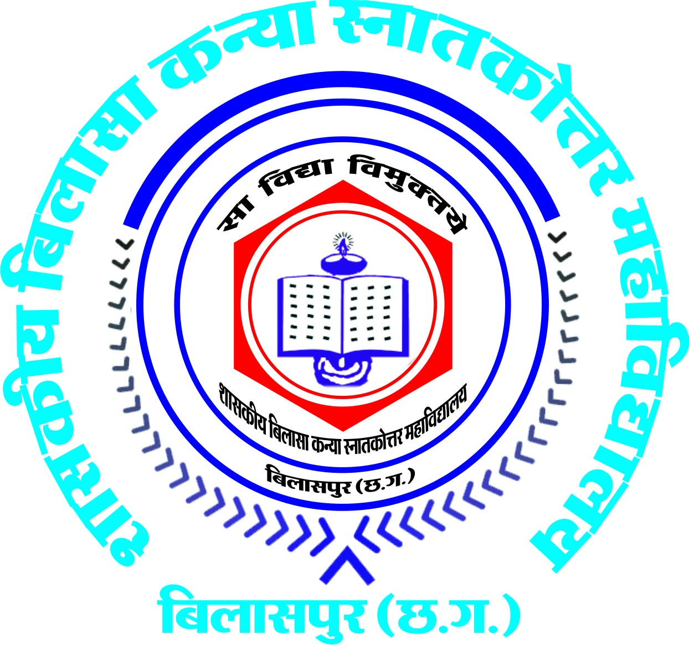

Submitted by
Govt. Bilasa Girls P.G.College Bilaspur (C.G.)
(Affiliated to Bilaspur University, Bilaspur)

Link Road, Bilaspur (C.G.) 495001
Tel. 07752-224249, 409952
Email: bilasagirlscollege_bilaspur@rediffmail.com
Website: http://bilasagirlscollege.ac.in

The Annual Quality Assurance Report (AQAR) of the IQAC

All NAAC accredited institutions will submit an annual self-reviewed progress report to NAAC, through its IQAC. The report is to detail the tangible results achieved in key areas, specifically identified by the institutional IQAC at the beginning of the academic year. The AQAR will detail the results of the perspective plan worked out by the IQAC. (Note: The AQAR period would be the Academic Year. For example, July 1, 2012 to June 30, 2013)

Part – A
1. Details of the Institution
Govt.Bilasa Girls’ P.G.College,Bilaspur(C.G.)
1.1 Name of the Institution
Link Road, Bilaspur(C.G.)
1.2 Address Line 1

Address Line 2
Bilaspur
City/Town
Chhattisgarh
State
495001
Pin Code
Bilasagirlscollege_bilaspur@rediffmail.com
Institution e-mail address
07752-224249
Contact Nos.
Dr. S.L.NIRALA
Name of the Head of the Institution:
07752-224249
Tel. No. with STD Code:

08839748096
Mobile:

Dr. Kaveri Dabhadker
Name of the IQAC Co-ordinator:
094241-45530
Mobile:
K_dab@rediffmail.com
IQAC e-mail address:

1.3 NAAC Track ID (For ex. MHCOGN 18879)_E&NER/BSM/2nd/CYCLE/CHCOGN12598/2013,27-11-2013
http://bilasagirlscollege.ac.in
1.4 Website address:

Web-link of the AQAR:
For ex. http://www.ladykeanecollege.edu.in/AQAR201213.doc

1.5 Accreditation Details
Sl. No. | Cycle | Grade | CGPA | Year of Accreditation | Validity Period
1 | 1st Cycle | B++ | 81% | 2006 | 2011-12
2 | 2nd Cycle | A | 3.04 | 2014 | 2019
3 | 3rd Cycle
4 | 4th Cycle

S.NO.852-A/NAAC/IQAC/14-12-2009
S.NO. 2101/NAAC/IQAC dated 30.12.14
1.6 Date of Establishment of IQAC :

2014-15
1.7 AQAR for the year (for example 2010-11)

1.8 Details of the previous year’s AQAR submitted to NAAC after the latest Assessment and Accreditation by NAAC ((for example AQAR 2010-11submitted to NAAC on 12-10-2011)
- AQAR 2009-10_Submitted to NAAC on (5/10/2013)
- AQAR_2010-11 Submitted to NAAC on (5/10/2013)
- AQAR_2011-12 Submitted to NAAC on (5/10/2013)
- AQAR_2012-13 Submitted to NAAC on (5/10/2013)
- AQAR 2013-14 Submitted to NAAC on (10/06/2014)
- AQAR2014-15 Submitted to NAAC on ( 12/7/ 2015 )
- AQAR2015-16 Submitted to NAAC on ( 30/1/ 2019 )

1.9 Institutional Status

University State Central Deemed Private
Affiliated College Yes No
Constituent College Yes No

√
Autonomous college of UGC Yes No

Regulatory Agency approved Institution Yes No
(eg. AICTE, BCI, MCI, PCI, NCI)

√
Type of Institution Co-education Men Women
√

Urban Rural Tribal

√

√

Financial Status Grant-in-aid UGC 2(f) UGC 12B

Grant-in-aid + Self Financing Totally Self-financing

1.10 Type of Faculty/Programme
√

√

√

Arts Science Commerce Law PEI (Phys Edu)

TEI (Edu) Engineering Health Science Management

PGDCA,DCA,Add-on courses,& BCA
Others (Specify)

1.11 Name of the Affiliating University (for the Colleges)
BilaspurUniversity,Bilaspur(C.G.)

1.12 Special status conferred by Central/ State Government-- UGC/CSIR/DST/DBT/ICMR etc
STATE
Autonomy by State/Central Govt. / University
UGC-CPE
University with Potential for Excellence UGC-CPE

DST Star Scheme UGC-CE

UGC-Special Assistance Programme DST-FIST

UGC-Innovative PG programmes Any other (Specify)

UGC-COP Programmes

2. IQAC Composition and Activities
6
2.1 No. of Teachers
1
2.2 No. of Administrative/Technical staff
1
2.3 No. of students
2.4 No. of Management representatives
1
1
2.5 No. of Alumni
2. 6 No. of any other stakeholder and
2
community representatives
2.7 No. of Employers/ Industrialists
2

2.8 No. of other External Experts
1
2.9 Total No. of members
02
]’
loiouyr
15
2.10 No. of IQAC meetings held 1
02
4
2.11 No. of meetings with various stakeholders: No. Faculty
1
2
5
Non-Teaching Staff Students Alumni Others
√

2.12 Has IQAC received any funding from UGC during the year? Yes No
300000=00
If yes, mention the amount
2.13 Seminars and Conferences (only quality related)
(i) No. of Seminars/Conferences/ Workshops/Symposia organized by the IQAC
2L
N
N
1
1
Total Nos. International National State Institution Level
Strategic planning ,Workshop on stress management
(ii) Themes
2.14 Significant Activities and contributions made by IQAC
Workshop on strategic planning of quality enhancement in higher education (13-2-2016) was organised.
Cleanliness of campus, New infrastructure facilities in college premises, renovation of hostel as well as construction of toilets, construction of college canteen is the new land marks of the college.
IQAC with the collaboration of career and counselling cell organised women’s empowerment and world women’s day celebration. It was one of an important programme in which distinguished women from different spheres of society were invited. Respected dignitaries of the Bilaspur city delivered speech and shared their experience with the students.
WIFI facility was provided throughout the campus by CHIPS.
NSS/NCC Unit of the college organised various programmes in the college like plantation, campus cleanliness, poster competition, digital training etc.
GUEST lectures, field studies, were conducted by various departments.

2.15 Plan of Action by IQAC/Outcome
The plan of action chalked out by the IQAC in the beginning of the year towards quality
Enhancement and the outcome achieved by the end of the year *

Plan of Action | Achievements
To Organise workshop  To organise student training  To organise Guest Lecture  Computerisation of central library  Projector installation in some of the teaching rooms of the college  Extension of Presentation facility in Auditorium.  Student personality development programmes  Social responsibility  Maintenance of the college premises | Workshop on stress management (23-9-2016) was organised.  Workshop on quality enhancement in higher education(13-2-2016)  Under Mukhyamantri Swavlamban Yojana student training was organised More than 540 students registered themselves for training, after that Examination was conducted Under Mukhyamantri Swavlamban Yojana student training (28-4-2017 & 29-4 17 by the state govt. 380 students were appeared in the examination . 50 students were selected for next stage.  In Department of geography , Chemistry , Urdu , Commerce ,Maths ,Zoology guest lecturers were organised.  Software is purchased for library automation. Work is in progress.  In geography, Home science, Zoology, &computer department installation of projector completed. In some other departments i.e. physics, botany projectors were purchased.  Completed.  Besides Regular teaching there are so many programms were organised in the college under the banner of NSS/NCC/RED CROSS/Departmental associations/ Student Union/Career & counselling cell.  Foundation day celebration, Plantation , Yoga Shivir. Digital india workshop, National integration rally, SWACHHATA karykram in and off the campus. Sarswati Pooja, Teachers Day, Annual gathering, annual sports etc.  Students of the department of Geography visited to village pad for environmental awareness campaign, Department of Home Science organised parents meeting in bhagini mandal Bilaspur, visit to old age home, socio-economic survey of village of karangara, bapaputi done by the student of Geography; RAKTDAN CAMPAIGN organised by the REDCROSS unit of the college.  This year lots of renovation work has been carried out by the college administration suggested by IQAC committee ie.car parking, girls hostel toilets, new class rooms, new canteen, With RUSA fund construction of new laboratories have been started.
* Attach the Academic Calendar of the year as Annexure. Annexure I

2.15 Whether the AQAR was placed in statutory body Yes No

Management Syndicate Any other body
Provide the details of the action taken
Action plan chalked out by the IQAC cell of the College was implemented through various committees and the department heads

Part – B
Criterion – I

1. Curricular Aspects
1.1 Details about Academic Programmes
Level of the Programme | Number of existing Programmes | Number of programmes added during the year | Number of self-financing programmes | Number of value added / Career Oriented programmes
PhD
PG | 17 | - | 02
UG | 5 | 1 | 1
PG Diploma | 3 |  | 3
Advanced Diploma
Diploma | 1 |  | 1
Certificate | 8 |  | 8
Others |  | 6skill based programme added | nil | 6
Total | 34 | 7 | 15 | 6

Interdisciplinary | -
Innovative

1.2 (i) Flexibility of the Curriculum: CBCS/Core/Elective option / Open options
(ii) Pattern of programmes:
Pattern | Number of programmes
Semester | yes, at P.G. Level & UG level
Trimester
Annual | yes, at UG level

Y
Y

Y
1.3 Feedback from stakeholders* Alumni Parents Employers Students
(On all aspects)

Y

Mode of feedback : Online Manual Co-operating schools (for PEI)
*Please provide an analysis of the feedback in the Annexure Annexure II

1.4 Whether there is any revision/update of regulation or syllabi, if yes, mention their salient aspects.
Yes –college has adopted semester system at first year of UG. Syllabi were revised accordingly. Single paper system in each subject is introduced as per university guidelines.

1.5 Any new Department/Centre introduced during the year. If yes, give details.
nil

Criterion – II
2. Teaching, Learning and Evaluation
2.1 Total No. of permanent faculty
Total | Asst. Professors | Associate Professors | Professors | Others
60 | 47 |  | 13

2.2 No. of permanent faculty with Ph.D.
53
2.3 No. of Faculty Positions Recruited (R) and Vacant (V) during the year
Asst. Professors |  | Associate Professors |  | Professors |  | Others |  | Total
R | V | R | V | R | V | R | V | R | V
47 |  |  |  |  | 13 |  |  | 60
18

2.4 No. of Guest and Visiting faculty and Temporary faculty

2.5 Faculty participation in conferences and symposia:

No. of Faculty | International level | National level | State level
Attended Seminars/ Workshops | 07 | 74 | 10
Presented papers | 07 | 74 | 10
Resource Persons | 02 | 21 | -

2.6 Innovative processes adopted by the institution in Teaching and Learning:
ICT based teaching, Interactive teaching adopted, field study incorporated in curriculum in many subjects

180
2.7 Total No. of actual teaching days
during this academic year
2.8 Examination/ Evaluation Reforms initiated by
Photocopy, challenged valuation valuation
the Institution (for example: Open Book Examination, Bar Coding,
Double Valuation, Photocopy, Online Multiple Choice Questions)
60
2.9 No. of faculty members involved in curriculum
restructuring/revision/syllabus development
as member of Board of Study/Faculty/Curriculum Development workshop

2.10 Average percentage of attendance of students 75 %
75%

2.11 Course/Programme wise
Distribution of pass percentage

Title of the Programme | Total no. of students appeared | Division
Title of the Programme | Total no. of students appeared | Distinction % | I % | II % | III % | Pass %
UG | 705 | 0 | 51 | 31 | 3.1 | 85.5
PG | 351 | 0 | 84 | 22.5 | - | 94.8

2.12 How does IQAC Contribute/Monitor/Evaluate the Teaching & Learning processes :
Through Academic Audit, IQAC assess the academic performance of each department and the faculty against the set targets for the year. Convenor of Academic Audit Committee, review each department and offer suggestions for improvement. Feedback from students regarding teaching is collected in which basis reformation of learning process suggested to AAC of college.
2.13 Initiatives undertaken towards faculty development
Faculty / Staff Development Programmes | Number of faculty  benefitted
Refresher courses
UGC – Faculty Improvement Programme
HRD programmes
Orientation programmes
Faculty exchange programme
Staff training conducted by the university | 6
Staff training conducted by college/ other institutions | 23
Summer / Winter schools, Workshops, etc.
Others
2.14 Details of Administrative and Technical staff
Category | Number of Permanent  Employees | Number of Vacant  Positions | Number of permanent positions filled during the Year | Number of positions filled temporarily
Administrative Staff | 31 |  | 01
Technical Staff | 16
Criterion – III
3. Research, Consultancy and Extension
3.1 Initiatives of the IQAC in Sensitizing/Promoting Research Climate in the institution
To promote the research environment in the institution, Research facilities are provided by the college through enhancement of infrastructure facilities in the laboratories. Guest lectures are organised to exchange the knowledge with students & faculties both.

3.2 Details regarding major projects
 | Completed | Ongoing | Sanctioned | Submitted
Number | NIL |  | - | -
Outlay in Rs. Lakhs

3.3 Details regarding minor projects
 | Completed | Ongoing | Sanctioned | Submitted
Number | 4 |  | UGC
Outlay in Rs. Lakhs |  | 01 | UGC

3.4 Details on research publications
 | International | National | Others
Peer Review Journals | 06 | 10
Non-Peer Review Journals |  | 53
e-Journals | 02 | 03
Conference proceedings | 01 | 04

3.5 Details on Impact factor of publications:

Range Average h-index Nos. in SCOPUS
3.6 Research funds sanctioned and received from various funding agencies, industry and other organisations
Nature of the Project | Duration  Year | Name of the  funding Agency | Total grant  sanctioned | Received
Major projects
Minor Projects
Interdisciplinary Projects
Industry sponsored
Projects sponsored by the University/ College
Students research projects
(other than compulsory by the University)
Any other(Specify)
Total | NIL

3.7 No. of books published i) With ISBN No. Chapters in Edited Books
06

NIL
ii) Without ISBN No.
3.8 No. of University Departments receiving funds from
UGC-SAP CAS DST-FIST

DPE DBT Scheme/funds
3.9 For colleges Autonomy CPE DBT Star Scheme
√
√

INSPIRE CE Any Other (specify)

3.10 Revenue generated through consultancy
Level | International | National | State | University | College
Number |  |  | 01
Sponsoring agencies |  |  | RUSA
3.11 No. of conferences
organized by the Institution
10
3.12 No. of faculty served as experts, chairpersons or resource persons
NIL
NIL
NIL
3.13 No. of collaborations International National Any other
NIL
3.14 No. of linkages created during this year
3.15 Total budget for research for current year in lakhs :
UGC-CPE

From Funding agency From Management of University/College
Total

3.16 No. of patents received this year
Type of Patent |  | Number
National | Applied | -
National | Granted | -
International | Applied | -
International | Granted | -
Commercialised | Applied | -
Commercialised | Granted | -

3.17 No. of research awards/ recognitions received by faculty and research fellows
Of the institute in the year
Total | International | National | State | University | Dist | College
05 |  | 04 |  |  | 01

3.18 No. of faculty from the Institution
20
who are Ph. D. Guides
and students registered under them
15

3.19 No. of Ph.D. awarded by faculty from the Institution
NILLL

3.20 No. of Research scholars receiving the Fellowships (Newly enrolled + existing ones)
nil
nil
JRF SRF Project Fellows Any other
nil

3.21 No. of students Participated in NSS events:

05
University level State level
National level International level
05
NIL

3.22 No. of students participated in NCC events:
NIL
62
University level State level
National level International level
09
NIL

3.23 No. of Awards won in NSS:
N
University level State level
NIL
National level International level
N
NO9IL

3.24 No. of Awards won in NCC:
University level State level
N
02
National level International level
02
N

3.25 No. of Extension activities organized

03
University forum College forum
08
20
20
NCC NSS Any other

  - Major Activities during the year in the sphere of extension activities and Institutional
- Student of the NSS unit visited to village Pand and Bahtarai and distribute the tablets among children for eradication of worms . they also give the information to the villagers in every squre of the village for preventive measures to eradicate infections from worms and importance of cleanliness(10-2-2017)
- Swachhata rally by college students (2-1-2016)Swachhata Karykram in Sardar Vallabh Bhai Patel Hospital, Brihaspati Bazar, and College premises was also organised.
- Department of Home Science participated in camp organised by NSS unit of the college in village Pand and health check up, BP checking and distribution of Magic Laddu are some activities done by the students along with the teachers of the department.
- Students of M.H.Sc.Human Development Department visit to Old age home, Orphanage home (Sewa Bharti,Matruchaya)and Shri clinik Bilaspur to serve the elderly persons and Mentally retarded children. One day awareness campaign in nearby village of Bilaspur to aware the people for utilising the various govt, schemes for child and women development, was also organised by HD Department.
- To study the hilly and river features 11days study tour organised by department of Geography.40 students along with faculty members visited Jabalpur –Panchmadhi region of Madhya Pradesh
- One day environmental awareness camp organised by department in village Pand. Students visited door to door and distributed the pamphlets regarding various issue related with environment, education, Social beliefs etc.

Criterion – IV
4. Infrastructure and Learning Resources
4.1 Details of increase in infrastructure facilities:
Facilities | Existing | Newly created | Source of Fund | Total
Campus area | 17acre | nil
Class rooms |  | Proposal accept for construction of 6 class rooms | C.G. Govt. | 10000000
Laboratories |  | Construction of laboratory work started | RUSA | 5000000
Seminar Halls
No. of important equipments purchased (≥ 1-0 lakh) during the current year. |  | -
Value of the equipment purchased during the year (Rs. in Lakhs) |  | 1384001
Others

4.2 Computerization of administration and library
Automation of examination system has completed. Library software purchased for automation of book distribution and keeping process..

4.3 Library services:
 | Existing |  | Newly added |  | Total
 | No. | Value | No. | Value | No. | Value
Text Books | 53000 | - | 1862 | 329600 | -
Reference Books | 1239 | - | - | 139643 |  | -
e-Books
Journals | 40 |  | 01 | 7000.00 | 41 | -
e-Journals
Digital Database
CD & Video
Others (specify)

4.4 Technology up gradation (overall)
 | Total Computers | Computer Labs | Internet | Browsing Centres | Computer Centres | Office | Depart-ments | Others
Existing | 175 | 03 |  | 01 | 01 | 01 | 17
Added | 08 | 00 | College campus facilitate by WIFI networking system | - | - | - | 02
Total | 183

4.5 Computer, Internet access, training to teachers and students and any other programme for technology
upgradation (Networking, e-Governance etc.)
Through skill based programme about 65 students get benefitted by the training of fundamental of computer training 65 student got fund

4.6 Amount spent on maintenance in lakhs :
170645
i) ICT
5000000
ii) Campus Infrastructure and facilities
1384001
iii) Equipments
128790
iv) Others

6683436
Total :

Criterion – V
5. Student Support and Progression
5.1 Contribution of IQAC in enhancing awareness about Student Support Services
Renovations and computerisation of library is essential for automation and proper library facilities provided to students. IQAC committee passed the proposal for enhancement of such works in library.
Besides the government scholarship programme, as per the decision of governing body of the college , cash prize and medal to topper students of each faculty has been given as token of appreciation .This practice provoke the healthy competition among students that is eventually helpful to create academic environment of the college.
Under the banner of NSS, the members of IQAC visited to nearby village and delivered the lectures on various topics. Students also participated in the various activities organised during the camp.
Lab to land exercise is the integral part of the study. With this department of geography, Home Science, Chemistry , Library science had gone to field studies, socio-economic survey , industrial sector , laboratories .It helps the students to acquire the knowledge of ground reality.

.2 Efforts made by the institution for tracking the progression
- Teachers pay special attention towards the weak and poor students of the college, they provide notes , take extra classes , to improve their academic endeavour. In some cases teachers pay fees of poor students to give them opportunity to excel in life. We do such practices on regular basis
- Students give their feedback every year for course, syllabai, and teachers, Institution take care of recommendations suggested by the students and make changes in academic , infrastructure and other programmes accordingly.

5.3 (a) Total Number of students
 | PG | Ph. D. | Others
 |  | 10

(b) No. of students outside the state
06
nil
(c) No. of international students

Men Women
No | %
No | %
 | 100
Last Year |  |  |  |  |  | This Year
General | SC | ST | OBC | Physically Challenged | Total | General | SC | ST | OBC | Physically Challenged | Total
836 | 569 | 482 | 1185 | 12 | 3072 | 926 | 546 | 672 | 1485 | 04 | 3633
Demand ratio 1:20 Dropout % 12
5.4 Details of student support mechanism for coaching for competitive examinations (If any)
This year semptember2016 to February 2017 a free coaching programme was carried out by faculties of the college for CGPSC entrance exam.

60
No. of students beneficiaries

5.5 No. of students qualified in these examinations
NET SET/SLET GATE CAT
01

IAS/IPS etc State PSC UPSC Others
NIL
03
NIL
NA

5.6 Details of student counselling and career guidance
At the very outset of every Academic Session an Induction Programme is organized to let the students of First Semester familiarize with the Rules & Regulations of the college along with the facilities available in the college. In the present Academic Session 2016-17 too, an Induction Programme has been organized on the 22nd & 23rd of August, simultaneously for B.A./B.Com. and B.Sc./B.Sc.(H.Sc.)/ B.C.A. First Semester students. All the faculty heads and in-charge of various committees were present in the programme and rendered information to the students about their committees and their working. Dr. S. R. Kamlesh, Principal of the college and Dr. Kiran Vajpai, Convener, Disciplinary Committee invoked the students to maintain discipline of the college.
Programme has been conducted by Dr. Manju Madhuri Bajpei and Dr. Pushpa Bhandari and vote of thanks has been rendered by Dr Sangeeta Shukla.
Time to time various information regarding the career and the personality development of the students have been notified on the notice board of the college to make them aware about the programmes of the Government and also of some private institutions.
It has been resolved that this year under the Career & Counseling Cell the students of the college will be introduced with the women who work for the welfare of the society. In continuation of this, on 6th October Mrs. Harshita Pandey, President of National Woman Commission has been invited along with the Registrar of Bilaspur University, Dr. Indu Anant and Renuka Pingle, social worker. All of them shared their experience with the students and resolved their queries too. Dr. Kaveri dabhadkar has conducted the programme and vote of thanks has been given By Ms. Sonati Patel, President Students’ Union of the college.
Furthermore, on the 8th of March, 2017 on the occasion of World Woman’s Day Dr. Kiran Vajpai, Principal has decided to organize a programme under the banner of Career & Counseling Cell and IQAC to felicitate the women of various fields who worked for the welfare of the society without any benefits and recognition. This programme has been organized for all the students to get them familiarized with these women and also their selfless services for the society as well as for the nation. Eight women have been honoured, Ms. Kamla Dasaz, Retd Principal, devoted her life for girl’s education. Dr. Nalini Dixit, served in the field of health. Dr. Pushpa Dixit, Retd Professor of Sanskrit, honoured by the President of India by the President Award, Mrs. Sharda Rahalker, social worker, working for the children of leprosy patients. Mrs. Mamta Mishra, a social-worker, devoted her life for deaf and dumb children. Ms. Shobha Mishra, otherwise abled, has been spreading the light of knowledge among the blind students. Mrs. Nisha Kanasker, social worker, running an Orphan House with great care and love. Mrs. Angha Kulkarni, social worker were present in the programme and shared her experience with the students of the college. All the above mentioned role model women shown the path of integrity and honesty with dedicated hard work to the students of the college who are going to become the responsible citizens of India tomorrow. Dr. Kiran Vajpai, Principal of the college honoured them with shree-fal, shawl and Memento. Programme has been conducted by Dr. Manju Madhuri Bajpei and Dr. Kaveri Dabhadkar and vote of thanks has been given by Dr. Sangeeta Shukla.
In the continuation, on the 20th of March, 2017, Mrs. Niharika Barik Singh, Commissioner, Bilaspur has been invited for the counseling of the students. She insisted that girls should decide and focus themselves from the beginning what they want to become. Dr. Gauri Dutt Sharma, Vice Chancellor, Bilaspur University and Dr. S. R. Kamlesh, Principal Govt. M.L.S. College Seepat were also invited to render their valuable guidance to the students. Dr. Kiran Vajpai, Principal has informed the guests that this institute has been doing enormous efforts for the welfare of the girls students.

900
No. of students benefited
5.7 Details of campus placement
On campus |  |  | Off Campus
Number of Organizations Visited | Number of Students Participated | Number of Students Placed | Number of Students Placed
MYSY Scheme of CG govt. | 584 registered | 50 students cleared the examination | 50

5.8 Details of gender sensitization programmes
Under the theme of Women empowerment a lecture proogramme was organized by the career and counseling cell to motivate the students to improving their skills, personality for batter survival in society.

5.9 Students Activities
5.9.1 No. of students participated in Sports, Games and other events
17//17
00
00
State/ University level National level International level

No. of students participated in cultural events
00
00
00
State/ University level National level International level
5.9.2 No. of medals /awards won by students in Sports, Games and other events

WINNER-Cricket, Badminton, Table tennis
Sports : State/ University level
nil
National level International level nil

Cultural: State/ University level National level International level

5.10 Scholarships and Financial Support
 | Number of  students | Amount
Financial support from institution
Financial support from government
Financial support from other sources
Number of students who received International/ National recognitions
5.11 Student organised / initiatives
01
nil
nil
Fairs : State/ University level National level International level
Exhibition: State/ University level National level International level
nil
nil
nil
10
5.12 No. of social initiatives undertaken by the students

5.13 Major grievances of students (if any) redressed: _______Nil_______________________________

Criterion – VI
6. Governance, Leadership and Management
6.1 State the Vision and Mission of the institution
Vision
“saa vidhyaa yaa vimuktaye” ( Vishnu Puran 1.19.41)
means Knowledge is that which liberates
Adhering to the dictum, the college is making relentless efforts for liberation and empowerment of young women of region by imparting knowledge.
Mission
  - To create a healthy academic environment for promotion of quality education.
  - To provide the education to girls’ student in such a way that they may become the part of economic society
  - To conduct research and training programmes for increasing the level of knowledge in various field
  - To carry out need based and value based education for community development.
  - Promote applied aspects in studies for self-reliance and self- employment.
  - To organize co-curricular and extracurricular activities for over all personality development of students.
  - To promote innovations in planning, teaching and evaluation to achieve higher scales of perfection.

6.2 Does the Institution has a management Information System
Yes, we have the participative management information system. Principal plays a leading role in governance of the college. He constitutes different committees involving the staff member for the proper execution of college development plans and the information is provided to all.

6.3 Quality improvement strategies adopted by the institution for each of the following:
6.3.1 Curriculum Development
For smooth running of the semester system both UG &PG level in the meeting of HOD’s of all the departments decided for minor changes in curriculum in this year.
Some amendments in semester regulation has been made for welfare of the students as well as to fulfil their demands with due permission of parental university.
More emphasis was given to field knowledge. Botany, Zoology, Chemistry , Human development and Geography department incorporate the field studies in their curriculum.
As per the semester/CBCS/Honors system regulation adopted by the college, in most of the departments CBCS courses execute i.e. Botany , Zoology Commerce etc..

6.3.2 Teaching and Learning
- Institution follows the conventional as well as modern methods.
- Time table committee sets up the class room teaching properly. Head of the faculty check the daily diaries of the faculty to assess the teaching plan as per scheduled by the teacher ,finally at the end of each month it is counter signed by principal. Such practice make the teaching well planned.
- Interactive sessions are held in the respective departments for the exposure of the students.
- Many of the departments organises lab to land activities to enhance the ground knowledge to students.
- ICT TECHNOLOGY is used in Teaching especially for dissection in Zoology and during student seminar in each department.

6.3.3 Examination and Evaluation
. As per the semester system there is no provision of revaluation so to provide facility to student to reassess their answer book , Challenged evaluation system was introduced at UG level
Provision of Central valuation of answer books were also recommended by the Governing Body of the autonomous system of the college.
Poster presentation, field projects are made compulsory for the students of UG first semester in environmental studies.

6.3.4 Research and Development
Under the RUSA fund 6 new laborotaries are constructed and equipments are puechased that will be enhanced the research environment of the college.
Some of the faculty members completed their miner research project funded by the UGC (Dr. Sangeeta Shukla, Dr. Seema Mishra, Dr. K.P. Tiwari, Dr. Kaveri Dabhadker).
More than 49 research papers of the faculty members were published in national and international journals and all most all members participated in national seminar /conferences/workshops.
Two workshops were organised in college which gives a new vision to improve the quality of higher education.

6.3.5 Library, ICT and physical infrastructure / instrumentation
6.3.5 Library,
- A new software was purchased to upgrade the library. Automation .work in progress.
Books were purchased and distributed to students of SC, ST category

6.3.6 Human Resource Management
- Workshop was organised for student to motivate them about the stress management.
- For interaction of faculty members with the eminent women personalities of the city, a women empowerment programme organised in which they share their experiences with the teacher and students. This motivated the students and teacher to think about their behaviour, work culture and overall personality development.

6.3.7 Faculty and Staff recruitment
6.3.7
- To maintain and to keep college premises clean twelve daily wedges employees were appointed by college administration
- For smooth functioning of teaching and learning guest faculties were appointed in Sanskrit, Zoology, Commerce, Hindi, Maths, Urdu, Economics, Food and Nutrition, Library science

6.3.8 Industry Interaction / Collaboration
Being the members of various administrative committees of the college ( Acedemi counsil , Board of studies , governing body,Janbhagidari samiti ) interaction with the personalities of the industrial sector is established Their expert views and suggestions are valuable to formulate the planning of not only academic sector but also other fields also.
Students of Chemistry Department visited to coal India laboratory. Students of Home Science did their internal ship for nutrition in APPOLO Hospital Bilaspur.

6.3.9 Admission of Students
College follows the government rules for admission. To execute the admission process committees are formed.

Teaching | As per Government rules
Non teaching | ---do---
Students | ---do---

6.4 Welfare schemes for

-
6.5 Total corpus fund generated
yes

6.6 Whether annual financial audit has been done Yes No

6.7 Whether Academic and Administrative Audit (AAA) has been done?
Audit Type | External |  | Internal
Audit Type | Yes/No | Agency | Yes/No | Authority
Academic |  |  | Yes | Academic audit committee
Administrative | YES | GOVT. | Yes | Account audit committee

6.8 Does the University/ Autonomous College declare results within 30 days?
For UG Programmes Yes No
YES

YES

For PG Programmes Yes No

6.9 What efforts are made by the University/ Autonomous College for Examination Reforms?
- For smooth running of semester system examination calendar is declared by the autonomous cell in the month of July-august so that all the other activities can easily conducted..
- In Induction programme controller of examination gives information regarding the working of examination cell and examination pattern in details to students .
- I Stage of Automation of examination prossess is completed.
- Examination committee , moderation commite , result committe , unfare means reamady committee , udan dastta etc. Working throught the examination period for smooth running of the whole process.

6.10 What efforts are made by the University to promote autonomy in the affiliated/constituent colleges?
University gives full supports in all the essential formalities to run the autonomous system properly Decisions taken by the college regarding the course contents, examination patterns etc. are all most same or parallel to the university rules and regulations.
Markshhets, TR , Degrees are counter signed by the university .officials of the university are positively completed all the process this helps to complete the examination and declaration of results in time .
University nominees in BOS,ACEDEMIC COUNSIL , GOV.BODY plays an important role in overall development of the college academic , administrative aspects .

6.11 Activities and support from the Alumni Association
- Meeting of alumni association was held in the college . Alumani of the college took part in almost all activities of the college development. As a member of IQAC they are the part of planning board of the college.
- Alumani as the member of the BOS contribute to enhance the academic path of the college.
- In the meetings of alumni , suggestions and feedback made by them are valuble and helps to improve the personality of the college

6.12 Activities and support from the Parent – Teacher Association
In this academic session (2014-15) parent teacher meeting was organised by the college in the month of January. It gives the opportunity to the teachers to meet the parents of their ward. Feedback & tips derived from this meeting helps to improve the academic , infrastructural and other moods and shades of the college.

13 Development programmes for support staff
In our college besides academic work so many works assigned to teachers .all such kind of works completed with the cooperation of supportive staff.(examination, competitive examination, cultural activities , seminar , sports , purchase , cash book checking and other activities). These practices provide the supportive staff to learn not only technical but administrative aspects to handle the problems facing during the work and developed the capacity to work.
No formal training programme organised this year for development of support staff.

6.14 Initiatives taken by the institution to make the campus eco-friendly
“ SWACHHA BHARAT ,CLEAN BHARAT “ is the logo of india. College administration is always awere about the green and clean campus. Environment committee is always pay attention towards the cleanliness of the college .
Plantation programme was organised every year in the month of july-august. This year hostel garden was developed by the students of NSS/NCC.
All the staff members an gardeners of the college do the attention to keep the campus and garden clean .
Rotation of flowering plans in garden makes the college campus pleasent.
Use of Plastic is banned in the campus.
“SOKHATA GADHA ‘” has been made to deposition of the solid waste of the plants and thus organic fertiliser in college has been made .

Criterion – VII
7. Innovations and Best Practices
7.1 Innovations introduced during this academic year which have created a positive impact on the
Functioning of the institution. Give details.
Unused and waste material of all departments and campus that were dumped in everywhere has been throw out. This makes the campus clean and “space “ generated in the building . Cleaning and Renovations of old building in the campus and reuse of it, extended the built-up area of the college and it enhance the beautification of campus.
Free Special coaching classes for competitive examination is anew practice of this year helps the students to preparation.
Posters’ prepared by the first year on various aspects of environment were hanging through the college campus .These poster works as hanging encyclopaedia on environment and student get benefitted through it.
Skill based programme started from this year as compulsory paper in sixth semester . Tnrough these programme student can learn computer fundamentals , English speaking , functional hindi , Baking ,Urdu , Traslation proficiency which provide them to improve innovative communication skills.

7.2 Provide the Action Taken Report (ATR) based on the plan of action decided upon at the
beginning of the year

Proposed work Action taken Report
 | Organise workshop  Under Mukhyamantri Swavlamban Yojana student training organised  Guest Lecture  Computerisation of central library  Projector installation in some of the teaching rooms of the college  Extension of Presentation facility in Auditorium.  Student personality development programmes  Social responsibility  Maintenance of the college premises | Workshop on stress management (23-9-2016)was organised .  Workshop on quality enhancement in higher education(13-2-2016)  More than 540 students registered themselves. Examination conducted(28-4-2017 & 29-4 17 by the state govt. 380 students were appeared in the examination . 50 students were selected for next stage.  In Department of geography , Chemistry , Urdu , Commerce ,Maths ,Zoology guest lecturers were organised.  Software were purchased .work in progress.  In geography , Home science & Zoology , computer department installation of projector completed. In some other departments i.e. physics, botany projectors were purchased.  Completed.  Besides Regular teaching there are so many programms were organised in the college under the banner of NSS/NCC/RED CROSS/Departmental associations/ Student Union/Career & counselling cell.  Founders day celebration, Plantation , Yoga Shivir. Digital india workshop, National integration rally, SWACHHATA karykram in and off the campus. Sarswati Pooja, Teachers Day, Annual gathering , annual sports,etc.  Students of the department of geography visited to village pad for environmental awareness campaign ,Department of home science organised parents meeting in bhagini mandal Bilaspur,visit to old age home, socio-economic survey of village of karangara, bapaputi done by the student of geography.RAKTDAN CAMPAIGN organised by the REDcross unit of the college.  This year lots of renovation work has ben carried out by the college administration suggested by IQAC committee ie.car parking, girls hostel toilets , new class rooms , new canteen , using RUSA fund new laboratory construction work starts.
Organise a Workshop on quality in higher education |  | Workshop organised on 13-2-2016workshop on stress management organised under the banner od placement cellon

7.3 Give two Best Practices of the institution (please see the format in the NAAC Self-study Manuals)
- Celebration of annual function
- Women empowerment

* details in annexureI- Annexure III
7.4 Contribution to environmental awareness / protection
Environment committee of the college through out the tear working in direction of conservation of energy , proper use of water in campus and green belt of the college.
Student of the final year not only planted the plant in vassels but also went to nearby villages for environmental awareness
Plastic are banned in the campus ,all the teachers along with the student take responsibility to maintain the clean &green campus

No
7.5 Whether environmental audit was conducted? Yes No

7.6 Any other relevant information the institution wishes to add. (for example SWOT Analysis)
In the very beginning of the year an award of best college of the state in point of view CLEALINESS UNDER THE pnchmukhi yojana OF THE Chhattisgarh govt,
Strengths:
- Regular teaching using both traditional &modern way of teaching
- continuous assessment system
- Quality and value based education for backward , poor girls student
- Continuous efforts towards personality development
- Student project work, lab to land exercise,
- Social responsibility , extension activity in and off the campus
- Environment awareness programme in and off the campus. Green-clean campus
Weakness
- More computerization in official and other administrative process required
- Less use of English language
- Less research projects.
- Space availability for sports is insufficient
Opportunities
- Collaboration with research lab and other institutions
- Job oriented courses introduced that enhanced the demand ratio
- Leading women institution in the state to provide quality education
Threats
- Area of college taken by the govt. for other uses.
- Use of mobile by students increase that may declined the interest in studies
- Because of poor economic condition

8. Plans of institution for next year
Plans for upcoming year are as fallows:
Infrastructure
- Construction of garden in Inner parts of the college.
- Provide cooler ton each departments
- Purchasing of furniture, and other necessary things of daily routine in New hostel building .
- On line admission process will be stared from next session
.
Academic Quality

- To enhance academic environment of the college some more affords should be taken teaching i.e. group discussion, quize, ICT base teaching.
- Guest lecture, student seminar, inter departmental lecture will be organised
- Proposals for New courses will be sent to govt. For sanctioned so that student get more opportunity to get admission in job oriented courses.
- More coaching classes started
Student support :

- Motivational lectures will be organised by the career council cell,
- More vocational training programms will be run in the college with the collaboration of Tata Institute of social science. Initiative has been taken towards this.
- Organise social campaign for awareness in and off the campus

Note: Grant for the Construction of Labs (9) is sanctioned Under RUSA ,construction work in progress.

Name _______________________________ Name _______________________________

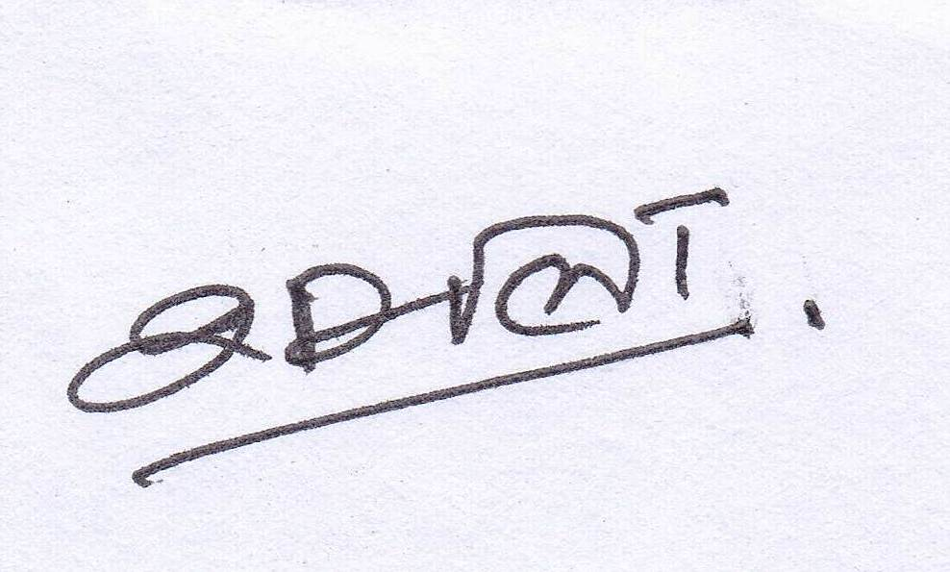



Signature of the Coordinator, IQAC Signature of the Chairperson, IQAC

_______***_______

Annexure I
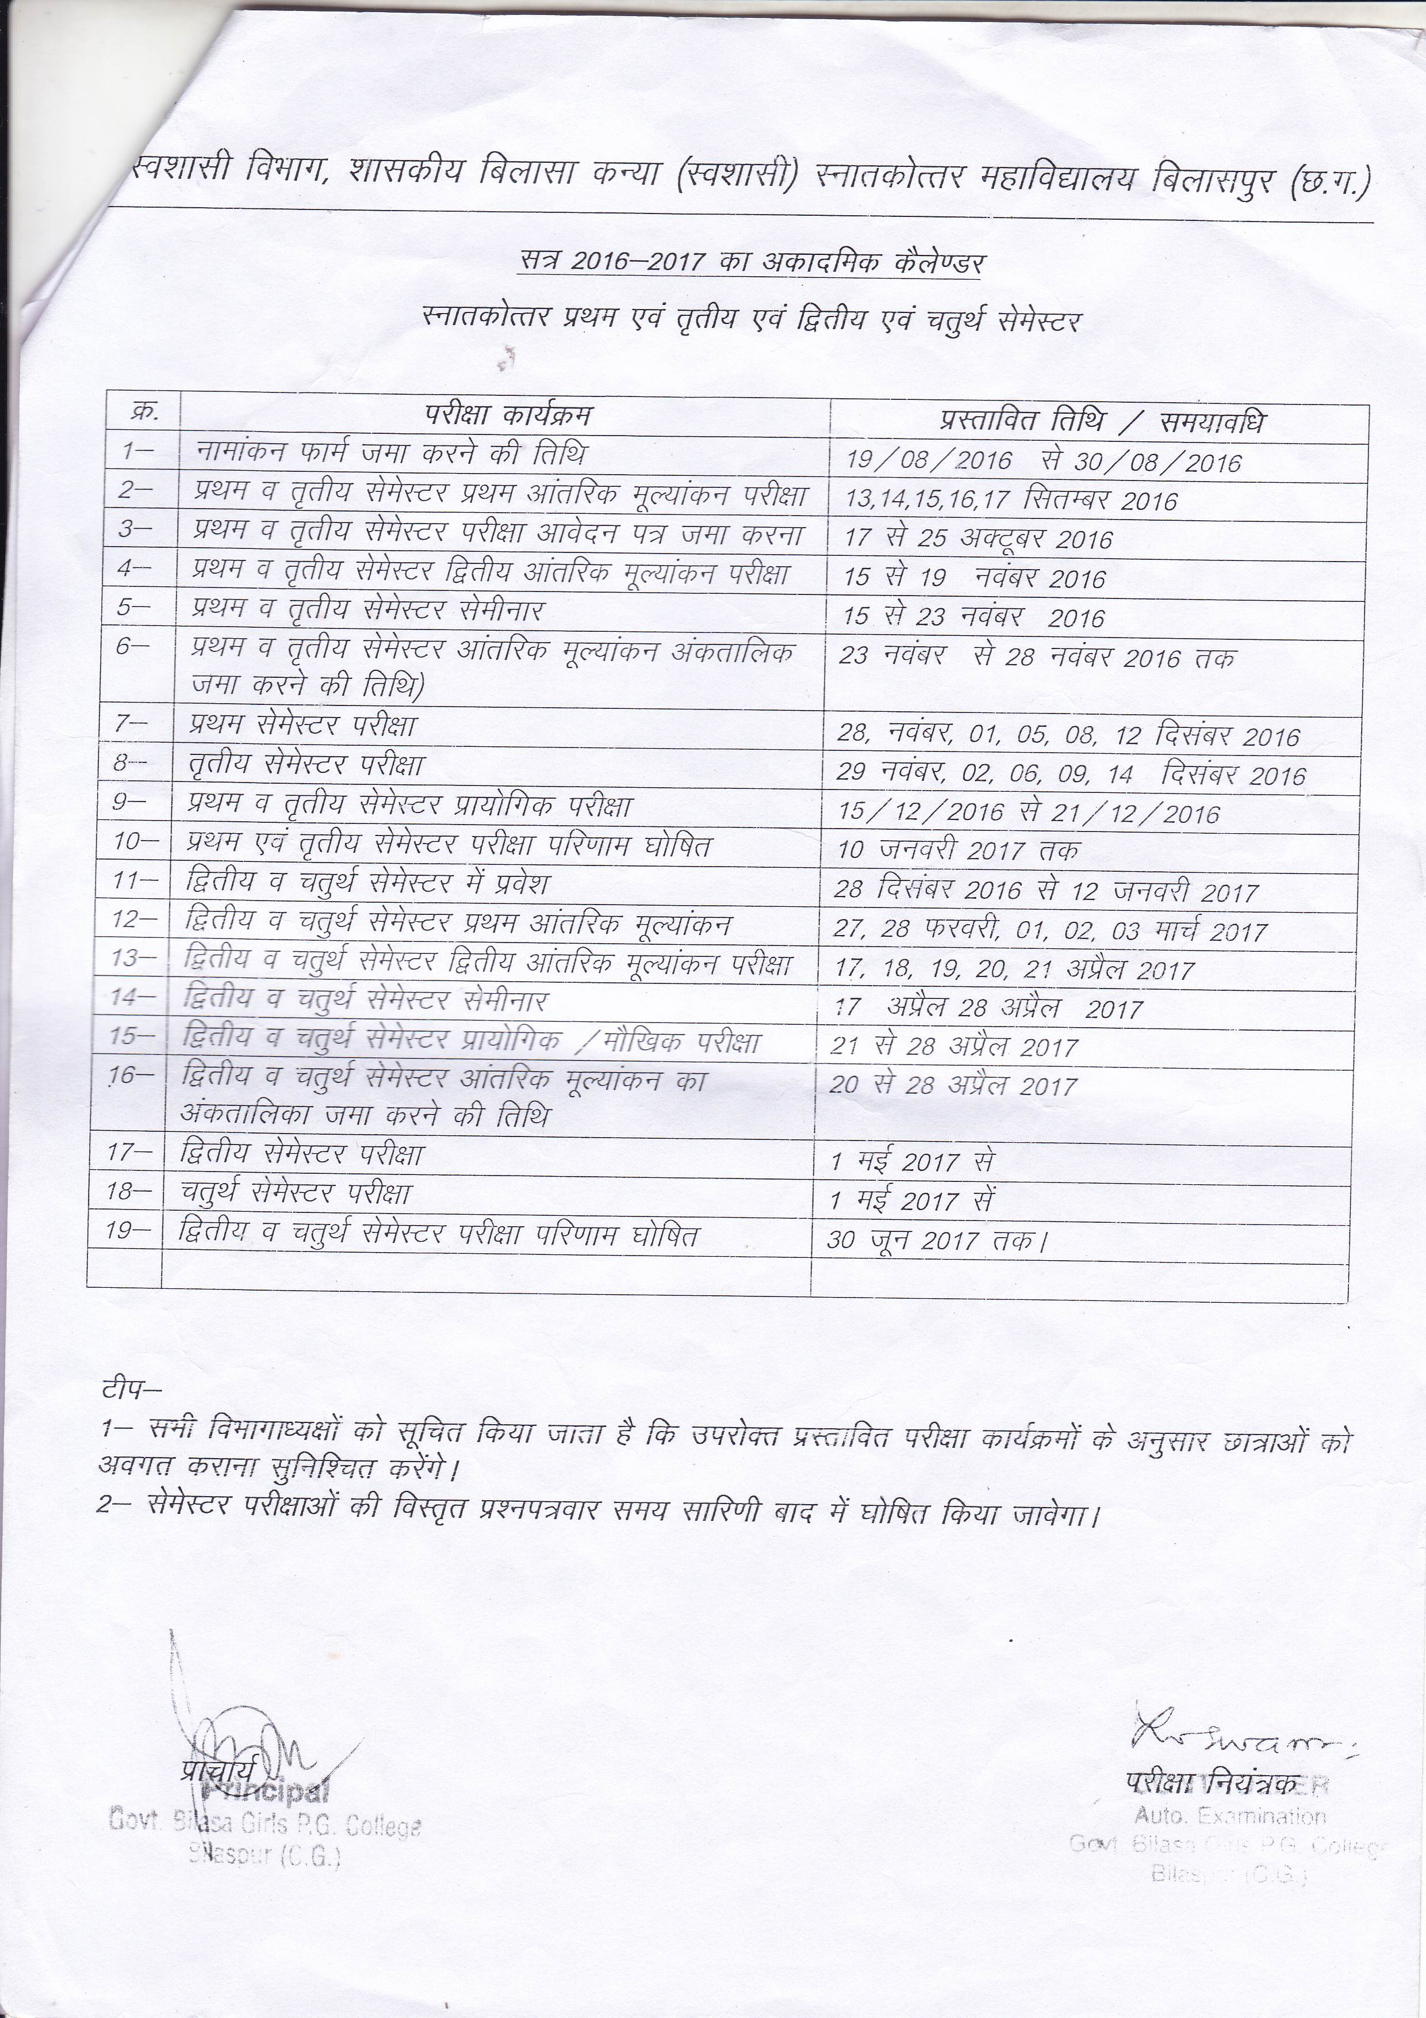
Annexure II

Govt. Bilasa Girls’ P.G. College Bilaspur (C.G.)
Analysis of Questionnaire No-1
Under Graduate- year 2016-17
Questionnaires for Feedback from Students: Course evaluation
Very Good Good Satisfactory Less Satisfactory

S.No | Question | Graphical analysis of student’s feed back
1 | Depth of the course content including project work if any | 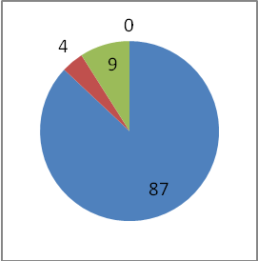
2 | Extent of coverage of course | 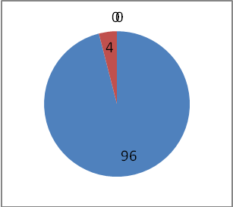
3 | Applicability/relevance to real life situations | 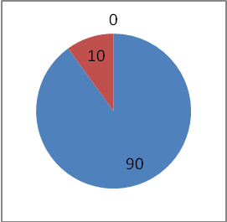
4 | Learning value (in terms of  knowledge, concepts, manual skills, analytical abilities and  broadening perspectives) | 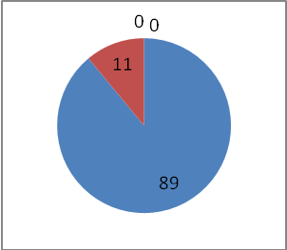
5 | Clarity and relevance of textual reading material
6 | Relevance of additional source material (Library) | 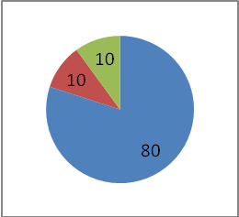
7 | Extent of effort required by students | 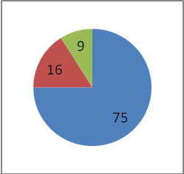
8 | Overall rating | 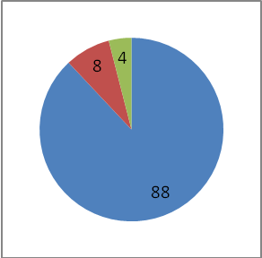

Dr Kaveri Dabhadkar Dr. S.L. NIRALA
Signature of Signature of
IQAC Convener Principal

Govt. Bilasa Girls’ P.G. College Bilaspur (C.G.)
Analysis of Questionnaire No-3
Under Graduate -year 2016-17
Student’s Overall evaluation of Programme and teaching
Very Good Good Satisfactory Less Satisfactory

S.No |  | Graphical analysis of student’s feed back
1 |  | 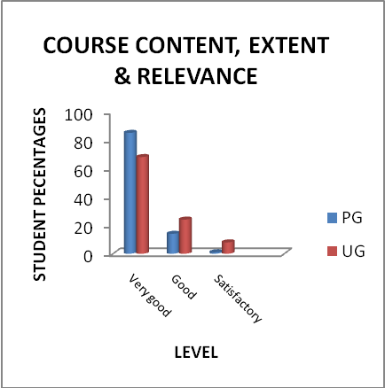
2 |  | 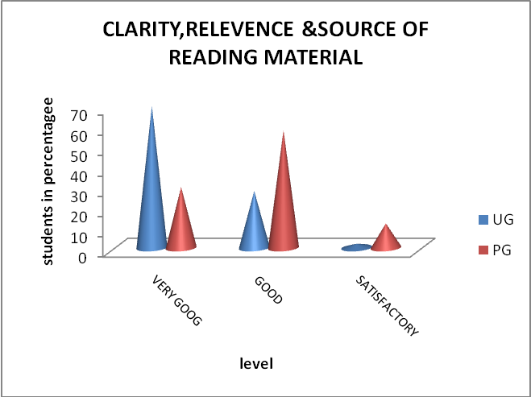
3 |  | 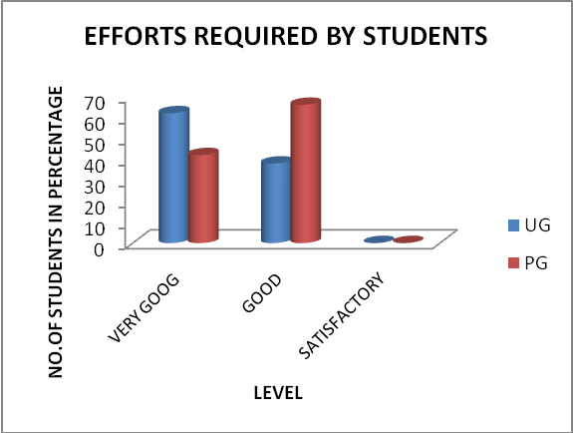
4 |  | 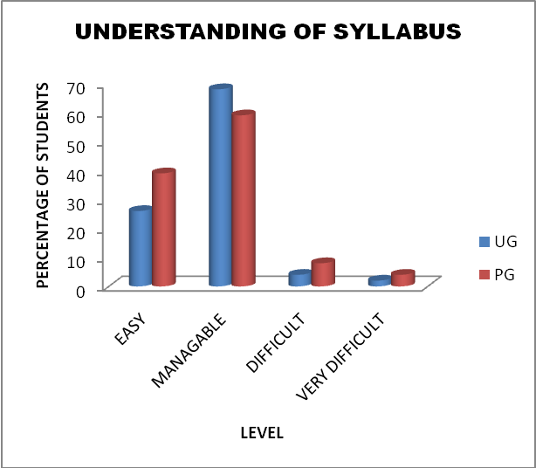
5 |  | 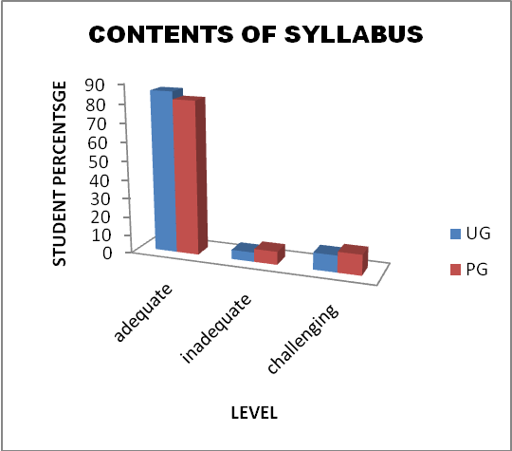
6
7 |  | 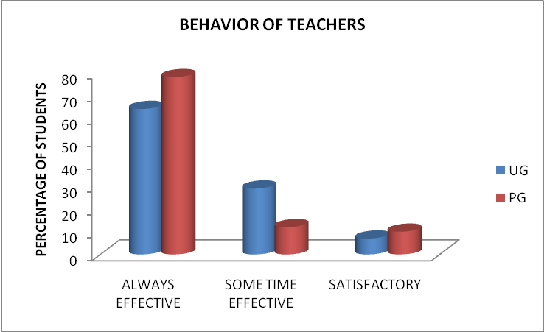
8 |  | 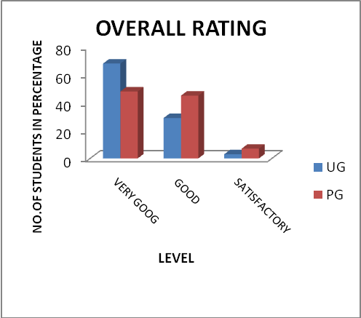

Dr Kaveri Dabhadkar Dr. S.L. NIRALA
Signature of Signature of
IQAC Convener Principal

BEST PRACTICE I
TRADITION OF CELEBRATION OF SOME SPECIAL EVENTS

Each college has its special characteristics by which its image is formed in the society. Bilasa girlls college is the leading institute of the bilaspur district established in july 1961. College has some special traditions those are continue till date. Such practices not only a step to preserve our tradition but the feeling of togetherness makes it more valuable. Most of the activities run by the students and coordinate by the teacher. The department organized these programmes are as follows:
1.Sarswati pooja - Geography – organized by student -since 1969
2. Teachers Day celebration- in all departments- students - 1971
3.NETAJI SUBHASHCHANDRA BOSE jayanti 2010
4 Science Day
5 Plantation – student – in the month of july-august-1980
6VASANTOTSAVA
7 FAREWEL & WELCOME ceremony- students-1980
- Staff Club
9.Foundation Day

Process
College is established in July 1961.so in the very beginning of the session we celebrate foundation day in which all the ex officio were invited .They share their memories with staff and also made suggestion for the development of the college in lecture session falloed by the lunch. It is a academic family gathering.
In the month of July under the banner of NCC/NSS uit of the college VRIKSHROPAN program was organized .Both students and staff participated in plantation programme
Spring season brings the glory of nature and with this music department enhance the beauty of nature by swar and tal . Artists from In & Off the college perform the
vocal music .It was started in the year of 1993-94 .Tradition of celebration of SARASWATI POOJA is another important occasion of the college which is celebrate on Basant Panchmi. .Initially it was started bt Department of geography in the year of 1968.It is still in a practiced in the geography department .Recently it is celebrated by all the departments of the college .student participation is appreciated to execution of this Pooja.
Obstacles
Celebration of these days are important as it is concern with our tradition and each has spiritual and national values but the students some time did not show their interest to organized these if it is one day prier or after the vacation period.
College administration sometimes not in favor to organized such functions like vasantotsav because of disinterest in music.
Examination schedule specially internal tests students do not want to involved during celebrations specially classical music programme.

BEST PRACTICE II
GREEN CAMPUS- CLEAN CAMPUS
Context:
Environmental degradation is the most burning issue of the world .everyone in the world faces various problems generated due to improper use of resources .Vegetation is one of the important element of the earth that preserve the planet earth and off course human being .Balance man and vegetation ratio is essential for the surveillance of man hence save the green blanket is prime necessity. Our college is spread over an area of17 acre of which about 4-5 acres having lush green cover that makes the environment of the college aesthetically beautiful but also balance the temperature of the campus specially in summer seasons. Clenliness is another important aspect of the environment that plays an vital role to maintain the campus logitivity. Thus the green campus and clean campus is the best practice of our college.
Process :
Green campus is the efforts of years and years .Every year in the month of July the students and the teacher celebrate the vrikshropan mahotsave .NCC , NSS unit of the college plays a role to watering the plants. Students of B.A. /B.sc. I semester assigned a project to plant a species in a earthen pot and take care of it throughout the year for this activity , all the students are divided into groups and it is the responsibility of that group thus students participation in protection of green campus is remarkable. Environment committee take care of plants , plantation of seasonal species , Department of Botany take responsibility to maintenance of Botanical garden and naming of plants. Use of pesticides , fertilizers for the growth and prevention of plants has been monitored by the committee .Gardeners are appointed by the college for gardening work of day to day.
College premises has four garden with flowering , medicinal ,local mansoon vegetation like Mango , Sheesham , Neem , Aawala ,Peepal trees.To clean the weeds in the garden and the prmises NSS students and college staff organized the clean campus programme once in two months.
Cleanliness of the classroom , lobbies ,laboratories is one of the remarkable feature of our primises. The college has been divided in to zone and each department has responsibility to clean their zone .Lab attendant works along with the sweepers to clean their assigned section. Daily three times cleaning of Toilet of the premises , cleaning of college lobbies daily makes the hygienic environment. It is a matter of pride that college has been awarded the best college of the state in clean premises under the PANCHAMUKHI programme in the year 2016-17.

Obsteclas:
Some time due to insufficient staff cleaning of the campus is affected. Failure of electricity is another problem the college faces the shortage of water both for gardening & cleaning of toilets ,it was the worst part of it .Although college administration immediately take action to resolved it but technical faults take time to repaired ,this ultimately causes unhygienic situation.

